

ALLISON TRANSMISSION, INC. (ATI)

PACKAGING MANUAL

PACKAGING, IDENTIFICATION, AND GLOBAL SUPPLY CHAIN REQUIREMENTS

2024 EDITION (revised 2/9/2024)

Forward

Supply partners must collaborate with Allison Transmission, Inc. (ATI) to promote packaging methods to ensure production parts arrive at ATI facilities in the same quality condition in which they were manufactured. Suppliers are encouraged to work with ATI to continually improve packaging strategies. Changes in plant facilities, sales volumes, part designs and packaging/handling technologies, etc., demand constant attention to guarantee the safest and most economical packaging is consistently utilized.

Packaging is to be designed and used to:
- contain and protect the production parts
- help reduce inventory requirements (e.g. via small-lot ordering)
- promote efficient part access for the operator
- allow workspace flexibility
- minimize operator walk time
- minimize effort to open and present packaging for operators
- provide efficient and ergonomically acceptable manual and/or mechanical handling
- provide for effective use of plant space and delivery trailers
This document is published as a guideline and reference tool for ATI suppliers to assist them in providing appropriately packaged components.
ATI maintains a Returnable Container Program primarily for its On-Highway business segments. There are non-On-Highway components on the returnable program and there are On-Highway components that use expendables. These returnable containers are to be only used by Tier I suppliers to hold finished components produced for ATI. Unless deemed appropriate and authorized in writing by the ATI Returnable Container Coordinator, suppliers should maintain no more than one to two weeks of returnable containers and dunnage at their facility at any time.
ATI also uses returnable racks for shipping finished products on some models. These metal racks appear in this document as reference only at this time. The wooden expendable pallets used by ATI and any enhanced versions used for international shipping are not part of this document at this time.
The final decision to use returnable or expendable containers is ATI’s after working with suppliers in the AT-1703 process that defines packaging parameters. The AT-1703 process is an ATI Excel-based form which may ask suppliers to quote multiple packaging scenarios as the use of returnable containers is impacted by vendor location, vendor volume, availability of containers, ergonomics, and lineside material presentation.
ATI’s packaging group will define the guidelines of a packaging definition on the form AT-1703. Any use of any expendable containers, packaging materials, or preservation materials is to be designed by the supplier who is responsible for its proper functionality. ATI may provide envelope sizes and may reject expendable packaging plans that do not suit the parts or the part presentation requirements. Packaging proposals are to be submitted using the AT-1703 process and pack plans must be approved by ATI prior to the first Production Trial Run (PTR) or the Production Shipment if there is no PTR. Any chemicals applied to components are subject to approval by ATI.
The net result is after proposals and requests to deviate from those proposals, the supplier and ATI come to a documented agreement on the packaging plan.
This document will provide a large number of requirements for shipment to ATI and will show the returnable program’s portfolio, plus sections dealing exclusively with expendable containers and dunnage. Examples of proper and improper use of packaging will be presented also.
Each supplier should provide a primary and secondary contact for packaging related activities. When personnel changes, the ATI Returnable Container Coordinators listed below should be contacted.
Questions or issues with this document or the ATI Returnable Program can be directed to:
Returnable Container Coordinators

Bill Bell 317-242-3710 (billy.bell@allisontransmission.com)
Kyle Hautala 317-242-6959 (kyle.hautala@allisontransmission.com)

Operator Presentation, Shelf Life, and Preservation Guidelines
Forward: A packaging plan is more than a box size and a quantity to put inside. Although the bulk of this document is dedicated to the defining and proper use of the container and internal dunnage, there are other criteria that must be followed and understood to make the pack plan repeatedly successful.
Operator presentation: The placement of parts into a container may have special orientation needs or restrictions on whether parts can or should be wrapped individually or collectively. Some large components may require special clearances to allow manipulators or hooks to enter the container and engage the parts. Hand room to grasp parts can also be a design driver. Even smaller components might have a requirement for a certain orientation inside the box or special markings on the boxes to indicate the front of the box if the packs are asymmetrical.
It is a goal of the AT-1703 packaging process to identify special needs that round out the packaging requirements and it is expected that these requirements be met at all times.
Shelf life: The cumulative effort of ATI and suppliers to design and provide precision components is squandered if the components arrive in a damaged condition. The physical damage can come from various sources and often those are easily addressable.
Damage due to corrosion, however, is a stealth predator to numerous components used by ATI. The potential damage is not limited to ferrous products and with ATI’s global sourcing and ATI’s global facilities, proper protection from corrosion is a very critical measure that must be undertaken to assure quality products.
Unless specifically stated otherwise on an AT-1703 packaging specification, the expectation is that all components achieve certain shelf lives. The shelf life is a period of time that a component can sit inside its original container without any physical degradation which would include rust, corrosion, drying out (seals), discoloration, or disfigurement.
The shelf-life requirements for the plants below start when ATI takes physical possession of the components which is usually when ATI’s carried picks up the components. The shelf life does NOT begin at the time of manufacture. Therefore, suppliers who may run in infrequent batches must package components considering the extended period of time the parts are in storage prior to shipment.
Minimum Shelf lives:
Plant 1391 (Docks 12, 14, 30, 31, 32, 33, 35, and 50) contracts: 30 calendar days
Plant 1392 (Dock 99) & Plant 1396 contracts: 90 calendar days
Plant 1394 (Docks 40 and 80) contracts: 120 calendar days
Any other direct ships to other plants or docks: 90 calendar days
Note that Plants 1391, 1392, and 1396 are in the United States and other plants are either outside of North America or a cross-dock for exportation.
It is the responsibility of the supplier to determine the magnitude of the preservation required to meet these requirements. ATI cannot control the supplier’s manufacturing lot sizes, the part packer’s carefulness, and the packaging/storage environment prior to shipment.
Shipments to the ATI cross-dock are usually handled by common carriers which are subject to weather variations during transit. Additionally, shipments to the non-US manufacturing plants are almost exclusively shipped by seatainer to places like Hungary and India. These seatainers may be above or below deck and subject to sea air and relatively hot and cold temperatures for extended durations.
These preservation requirements may call for drastic measures, but there needs to be a balance between incremental preservation costs and the ease of use by operators or automated assembly equipment. Also, many parts have restrictions on what preservatives can be directly applied to the parts due to chemical interactions with cutting machine fluids, assembly equipment, and the operators work environment.
Since the supplier controls the amount of time a component might sit in the supplier’s environment (which includes shipment from outside North American to a US-based domestic warehouse) and the actions of a domestic warehouse, suppliers are directly responsible for assuring that the parts delivered to ATI are in usable condition and maintain that status for the previously stated shelf lives and arrive un-damaged.

In almost all cases, the following preservation methods are not acceptable-
1). Wet rust-preventatives or oils (except with prior approval). All rust-preventatives, including dry to the touch products, must be approved by the ATI Materials Lab and the ATI Environmental Team prior to shipment. Products cannot be changed without ATI approval.
2). Any preservation product that might adhere itself to a component thereby requiring cleaning before use
3). Individual bagging or wrapping of parts (except with prior approval during the AT-1703 Packaging Process).
Expendable Packaging
What is expendable packaging?
Expendable packaging is any one-time use material used to house, envelope, wrap, protect, or cushion a component that is not provided by either the ATI Returnable Container Program or a vendor owned returnable packaging item. Expendable packaging also applies to any polybag liners used to line either a returnable or expendable container.
Note: The use of any supplier-owned packaging materials that are to be methodically returned to that supplier is extremely limited in use at ATI and approval of these items is very doubtful.
Expendable packaging items include, but are not limited to cardboard boxes, wooden or plastic pallets, cardboard divider pads, plastic sheeting, polybag liners of all types, foam sheets, bubble wrap, clean Kraft paper, labels, tapes, and banding.
Every packaging plan including a returnable packaging plan would have has at least one expendable item in it, and the cost of those expendable items should be included in some detail in the quotations solicited by the ATI Purchasing Department.
This document shall provide expectations and definitions of each expendable packaging item in order to reduce uncertainty of expectations.
Cardboard Containers
Cardboard corrugated containers are almost exclusively six-sided boxes that have four sides and top and a bottom that intersect at right angles. These containers may be called hand toted containers, carriable totes, cartons, or boxes.
For the purpose of this document, there are two types of cardboard containers:
- Hand toted containers that are at least 5” x 5” x 3” length x width x height and normally not exceeding 24”x24”x18” length x width x height, and, when packed, not exceeding 35 pounds in weight
- Larger, possibly multi-walled, containers that are used in combination with a non-integral expendable pallet which would not exceed a 45” x 48” x 34” envelope and should not hold more than 1200 pounds when packed.

Cartons/containers are to be designed to be modular to the standard size shipping pallet. Cartons must not overhang the pallet. The use of Half Slotted Container (HSC’s) with common covers is strongly recommended for high volume part applications. When using HSC’s, part numbers cannot be mixed on skids with other part numbers. HSC’s reduce packing and unpacking labor as well as reducing personal injury and part damage from the use of box knives or tearing off box flaps by hand. The use of uncovered (uncapped) HSC containers is not acceptable. Corrugated material used in hand carriable tote shipping containers with a packaged weight of 20 pounds or less must have adequate strength to withstand the test of usage and must be constructed from a minimum 200-pound Mullen test board (or equivalent crush test board). Totes from 20 up to 35 pounds must be constructed from a minimum 275-pound Mullen test board specification. Overseas suppliers must meet this specification and must provide documentation of their packaging’s ability to meet the requirements.

Cardboard bulk containers would be any container exceeding 35 pounds in total weight that would then require it to be palletized. Generally any container over 24x24x18 inches (length x width x height) regardless of weight is considered a bulk container.

Additionally:

All containers must be recyclable.

All containers must be “new” containers and not containers previously used for a previous shipment.

All pallet cartons over 33” in height must have a scored drop side. Although normally on the longer side of the container, the location and size of the drop side is determined by part orientation and operator ergonomics. The bottom of the drop side opening must be no more than 33” from the floor.

All containers must have a box maker’s certificate visible on the assembled container, and displaying edge crush, bursting or puncture test.

Wire-bound wood pallet boxes or wood and wood composite crates are not acceptable.

Bags, barrels, drums, kegs, cans, envelopes, or pails are not acceptable shipping containers for other than granular, liquid materials, or specially negotiated parts.

Expendable containers should be shipped on a quality pallet to the specifications defined in the Stacking/Palletizing of Expendable Containers section.

The maximum allowable height of a loaded pallet of hand toted expendable containers shall not exceed 42 inches or four containers high whichever is less.
Cardboard bulk containers cannot be secured to wood pallets with nails, staples, or adhesives as plant recycling efforts are circumvented by this configuration. These containers should be banded to the pallets with plastic banding.
For information on stacking and palletizing hand carriable containers, please see the Stacking/Palletizing section that appears after the Returnable Container examples.
Examples of Expendable Totes:

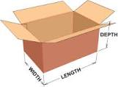
Expendable cardboard carton
- Regular slotted containers-four flaps top and bottom
- Lid flaps taped shut top and bottom
- Maximum weight with contents 35#
- Must be shippable small package ground (meaning it can be shipped on any side and not be damaged). Exceptions should be noted part by part.

Expendable cardboard carton
- Half- slotted containers-four flaps bottom only
- Shoebox style lid attached, secured usually by pallet banding
- Assumedly with straight side walls
- Lid flaps taped shut on bottom
- Maximum weight with contents 35#
- Hand holds may be required
- Lid must be secured if shipped small package ground (meaning it can be shipped on any side and not be damaged). Exceptions should be noted part by part.

Examples of Expendable Bulk Containers:
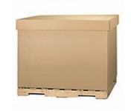
Expendable bulk container
- Pallets must comply with pallet requirements.
- Cardboard sides and mid may be single ply or multi-ply as needed.
- Shoebox style lid attached, secured usually by pallet banding.
- Box should not be secured to the pallet with nails, staples, or glue.
- Maximum weight with contents 1200#
- “Gaylord” boxes are an example of this style
Expendable Dunnage/Dividers
Expendable dunnage/dividers is defined as any non-returnable one-time use vendor supplied packaging component that is included as part of the piece price for physical part protection or part preservation that accompanies either a returnable container packaging plan or an expendable packaging plan. Wood pallets, strapping, and labeling are also considered expendable items and will not be returned to suppliers.
This includes but is not limited to polybag liners with or without VCI, desiccants, plastic wraps, bubble wraps, Kraft paper, cardboard dividers, chipboard dividers, plastic trays, tubes, caps, or ties.
Small toted containers that are stacked in multiple layers on pallets should have some container fill to avoid the crushing of the packaging and damage to its contents. The use of fill to eliminate air-gaps is also a requirement if the small toted container is shipped via a small package ground packaging service.
Suppliers are responsible for the design of these items, the procurement of these items, and the proper use to deliver components to ATI is an undamaged, ready to use state.

Examples of Expendable Dunnage/Dividers
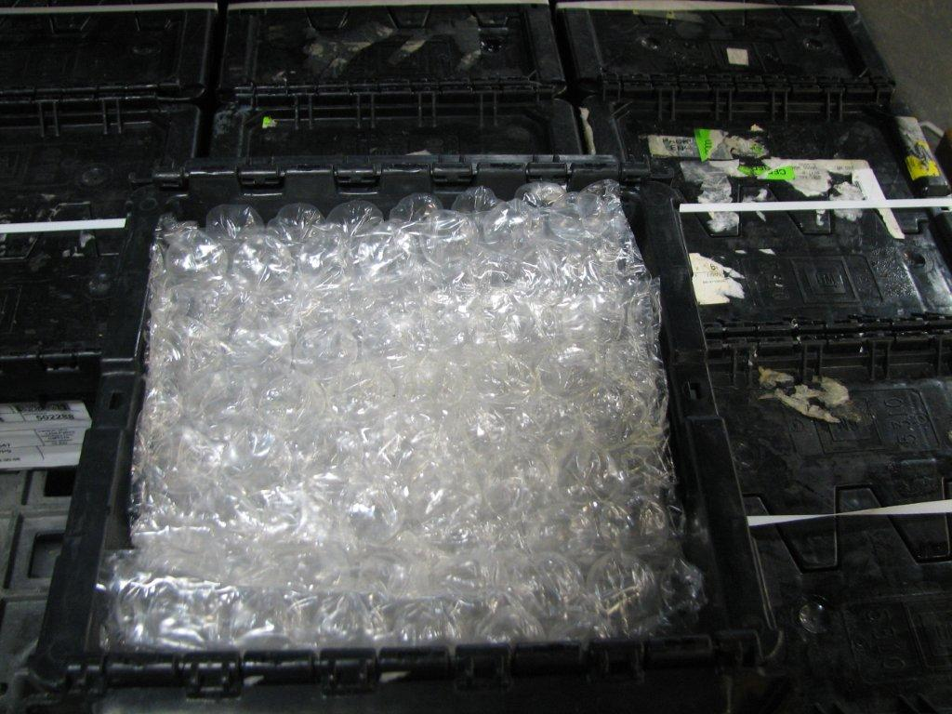
Clean plastic bubble wrap used to fill an air gap in a returnable GM5310 ATI returnable tote.

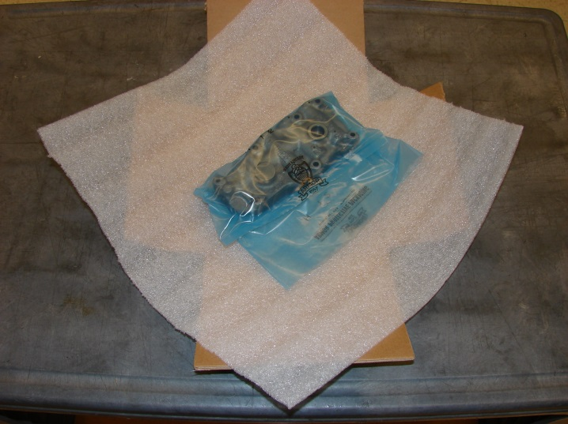
Individual VCI treated bag sitting atop a clean foam wrap.
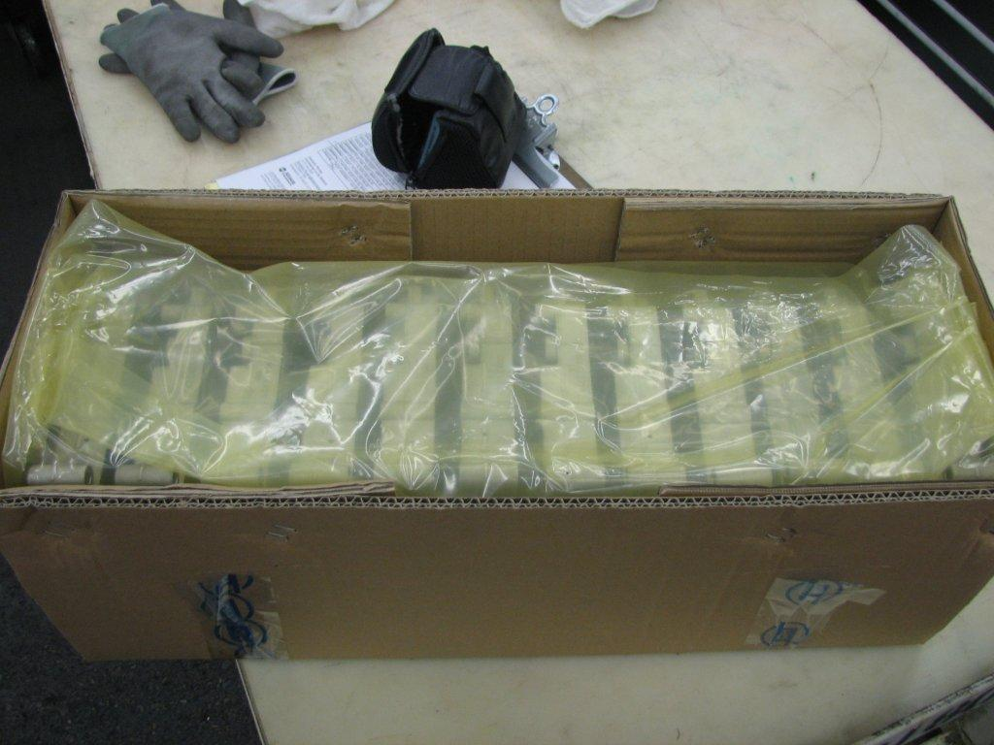
Half slotted container with parts in expendable internal tray lined with VCI treated polybag
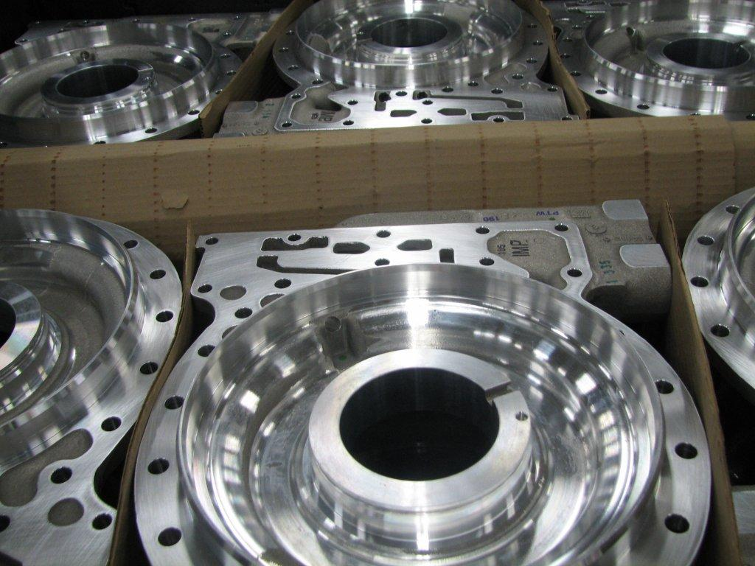
Expendable cardboard divider used with a bulk container to protect parts from handling damage
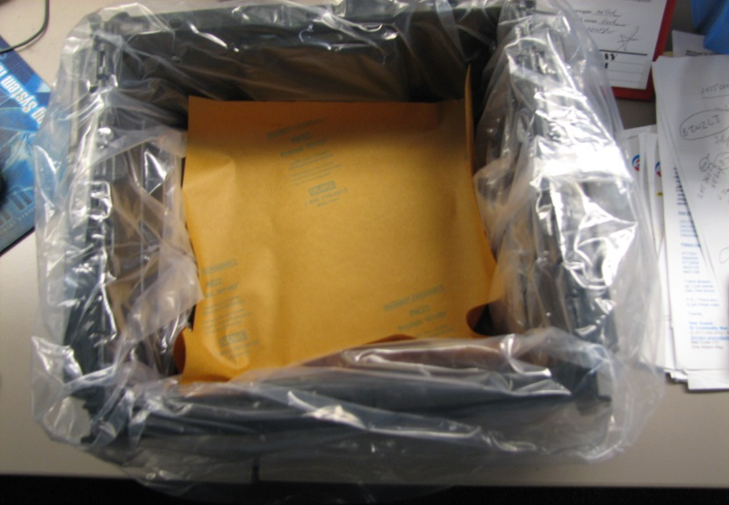
Returnable tote with plain polybag liner and VCI paper
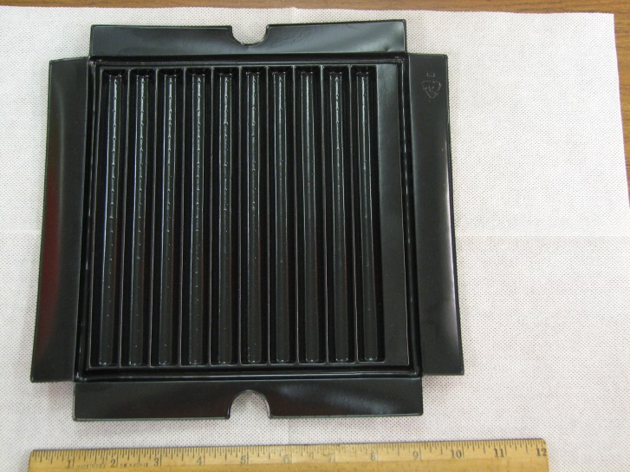
Clean Plastic wrapped cardboard dividers for both large and small package shipments.
Expendable valve tray-this sample fits the GM5310 tote.
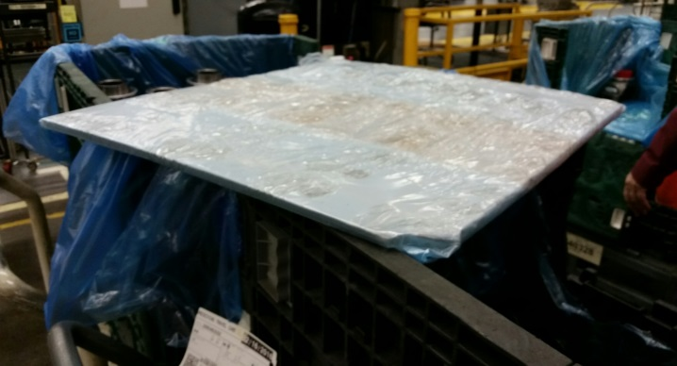

Polybag liners
A polybag liner is essentially a plastic bag that is placed into a container with the purpose of providing a cleanliness and an environmental barrier between the components inside and everything outside of it—the container, the air, moisture, etc.
Polybag liners may or may not be treated with a VCI type product to help prevent corrosion on parts that may be prone to corrosion.
Some lightweight parts in tote containers might only need a 2-mil bag as the bag serves as a cleanliness barrier.
Bulk containers and more robust parts might need up to a 4-mil polybag as there might be some opportunities to tear the bags during part and dunnage loading which may limit its intended effectiveness.
Unless specified otherwise, all parts shipped to ATI in any returnable or expendable container should have an appropriate polybag liner. There are exceptions and those are detailed and documented in the AT-1703 forms and process.
Securing Polybag liners
The standard practice for closing polybag liners is as follows:
The excess material from the polybag should be folded over the top of the loaded container.
On returnable bulk containers, some sort of lid (a layer pad), is placed over the top of the bag after it is folded and then that is banded.
On ATI tote containers with lids, if the closing of the lid keeps the folded bag top in place, i.e. there is no air gap, then that should suffice.
If there is a significant air gap, some parts may need additional fill to limit part movements during transit. This might be a bubble wrap or other clean plastic fill or Kraft paper. In all cases polybag liners should not be secured shut with cable ties, tape, staples, wire ties, glue, or anything else that would either impede a quick opening or would generate debris during removal.
Expendable Pallets

The recommended pallet size and construction is as follows:

Standard truck mode footprints are:

Length Width Tolerance

32” x 44” + 0, -1”

48” x 45” + 0, -1”

30” x 32” + 0, -1”

Pallet dimensions are stated in inches as follows:

Pallet length X Pallet width X Pallet height

Pallet length: the length of the stringer.

Pallet width: the length of the deck boards.

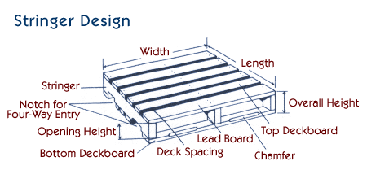

Overall pallet height: the vertical distance from the floor to the top of the deck- is 5 inches on all pallets.

Thus, a 45” x 48” x 5” pallet has 45” stringers, 48” deck boards and the top of the deck is 5” above the floor.

NOTE: For a four-way entry pallet, the primary (easy entry) opening is across the 48” width.

(By contrast, box and corrugated container manufacturers’ standard practice is to always state the larger dimensions first.)

Other Expendable Pallet Criteria

1). Responsibility for quality and performance of all expendable pallets rests with the supplier.

2). Vendor supplied plastic pallets are discouraged, but if they are to be used, they must be clearly marked with the appropriate recycling classification triangle visible from length dimension. These will not be returned to suppliers unless part of an approved supplier provided packaging system by Global Supply Chain Packaging personnel and ATI Purchasing.
3). All wood packaging material (including dunnage) that is imported for ATI at all plant locations worldwide MUST comply with the ISPM 15 (International Standards for Phytosanitary Measures - Guidelines for Regulating Wood Packaging Material in International Trade).
It is the supplier’s responsibility to conform to the requirements. Proof of this treatment will need to be marked accordingly on the outside of the packaging material.
Please visit web site: www.ippc.int. Suppliers that do not comply with this requirement are liable for all costs and fines incurred by ATI. These costs could include additional costs to clear the material for import (such as fines, fumigation costs, re-inspection costs, etc.) and costs that may be needed to cover production requirements during any delay to get material cleared through customs (such as expediting costs for additional material to maintain production).
The shipment of wood packaging material into major U.S. trading partners shall follow their countries’ regulations. Shipments from the United States to Canada and from Canada to the United States are exempt from ISPM 15.
4). Solid plywood decking may be used instead of individual top deck boards.
5). Top deck boards may have voids between them in forming the pallet deck, but the gap between the top deck boards must be at least ½ inch less than the width of the narrowest adjacent deck board. Too wide a span could cause some containers to split on the bottom as they straddle to wide an opening.
Stacking/ Palletizing Expendable Containers
As a general rule, expendable containers should not be stacked more than three containers high on a pallet or exceed 42 inches in total height including pallet.
Different size containers can be mixed on a pallet but must be sufficiently secured for shipment.
Part numbers can be mixed on pallets, but all containers on a pallet must be destined for the same Allison dock. Mixed loads must also have the appropriate AT-1724 Mixed Load labeling.
Containers should never overhang the edges of the pallet.
The use of packaging that requires “DO NOT STACK” signage should be limited, and container robustness may need to be added as stacking of palletized loads does occur in transit.
Securing Totes Not Shipped on Pallets

NOTE: The ATI Transportation Routing Instructions (AT-101106) outlines when shipments are to be made by small package ground transportation, less-than-truckload shipments, and truckload shipments.

There are some commodities that by weight or volume may qualify to be shipped by small package ground transportation, but tumbling of these parts in the container may damage them.

Suppliers should contact the ATI packaging coordinator or the Transportation Department if components must ship on pallets despite the relatively light weight. ATI will document the exception and it would apply to those part numbers specifically indefinitely.

Any ATI lidded returnable tote container that is shipped via the approved small package ground carrier will require additional securing of the lids. The options are to insert a cable tie into the slots at the far edges of the lid or to band, see below, or

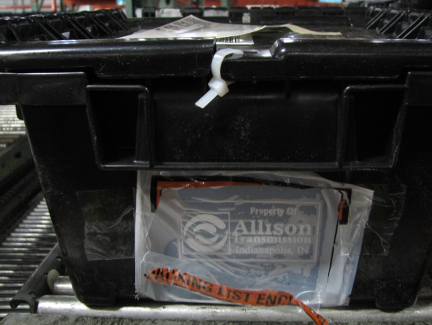

it is preferable to run a band around the entire container through the openings in the lid perimeter as shown below. It is much easier to remove the single band than the two cable ties.

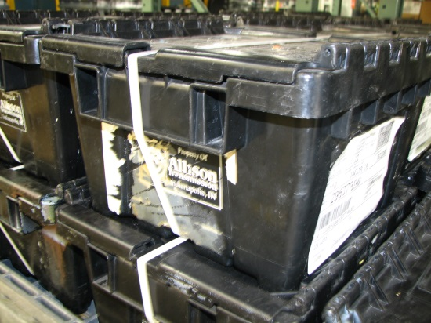

Conversely, any ATI returnable handheld lidded tote container that is shipped on a pallet should not have the lids secured in any fashion other than using the self- locking system for closure. If the container is defective and will not lock, return it to ATI per the process called out on the Returnable Container/Dunnage Request Form AT-101370 on the ATI vendor website or contact the ATI returnable container coordinators for assistance. If the pieces overload the container, contact the ATI returnable container coordinator to review the standard pack as it might exceed the capacity of the container and needs to be formally changed.
Securing Expendable and Returnable Hand-Carried Containers to Pallets

All containers shipped on pallets must be adequately secured to the pallets. Multiple containers must be properly stacked on and secured to pallets. Plastic strapping and plastic stretch wrap have been the acceptable method of securing cartons to a pallet. The assembly plants are working to recycle all packaging materials, including strapping and stretch wrap.
Part numbers can be mixed on pallets, but all containers on a pallet must be destined for the same Allison dock. Mixed loads must also have the appropriate AT-1724 Mixed Load labeling.

The following methods are to be used for securing cartons to a pallet:
- Plastic (Non-metallic) Strapping – Each tote or each stack of totes banded to a pallet should have one band lengthwise and one band widthwise must be used. Polyester strapping is required recommended due to its strength and recovery properties. Use of any other strapping requires approval by ATI and this is to be reviewed on a case by case basis. Non-metallic strapping must be joined with a “friction seal”. Metal clips or buckles are prohibited. The banding must be tight enough to secure all boxes on the palletized load and cannot be so tight that it damages the containers at banding contact points.

- Stretch film - Stretch film must be linear low-density polyethylene (LLDPE) and clear in color to maximize recycling potential. Polyvinyl chloride (PVC) film is not to be used.
Labeling Containers
The size and format of labels used to identify the contents of the containers or contents of mixed loads are defined in Allison AT-1704.
Placement of Labels – Totes: One label is required, two would be better placing one at each end of the container. Some totes have a defined label area either by Kennedy label, a metal edge that used to hold cardstock labels, or some build-up of not completely removed label remnants. Labels do not go on the top or the bottom of the containers.
Bulk containers: For this specification, a bulk container is any large container that is moved by fork truck using some sort of fork pocket in the container. This would include pallets with multiple totes as well as single part large containers or pallets with parts directly attached to them.
Two labels attached on opposite sides of the container are required. These should be on the sides that have the predominant fork pocket accesses. On the plastic bulk containers and large wire baskets, the predominant side is also the side with the access gates.
Any other shipping or special identification labels requested or required by ATI should be attached to the same sides as the container labels.
Packaging labels or any other items (i.e. vendor quality inspection stickers, company decals, etc.) should not be affixed to the inside of the container or onto any of the Allison supplied dividers.
Packing Slips
All shipments require packing slips to be included. Whenever possible, these documents need to be included in an easily accessible plastic pouch attached to the outside of the container.
The content requirements of the packing slips are defined in AT-1700 and in the ATI Purchasing Terms and Conditions.
Returnable Container Systems
Overview: ATI maintains a fleet of returnable containers, pallets, and layer pads/trays for select commodities. Program specifics follow here and in greater detail in the Frequently Asked Questions Section that follows.
The assets of the returnable container fleet are for the use of suppliers for the purpose of packaging finished material to be provided to ATI exclusively.
The assets of the program are not specifically maintained for one supplier or one component’s packaging plan. Other ATI suppliers may concurrently use this same packaging asset for the wide variety of components supplied to ATI.
Suppliers are responsible for ordering from the Cross-dock. For the most part, suppliers should maintain one to two weeks of ATI container assets at their facility either holding finished goods or not in service waiting to be filled with finished goods.
Some suppliers are asked to order when assets are needed in fixed lot sizes of containers or dunnage that may exceed the one-to-two-week guideline.
Some suppliers might be asked to order on a disciplined schedule such as a weekly request as the backhauling of these assets on higher volume suppliers is done on scheduled milk runs. Since volumes tend to be fairly level on the higher volume plants, the expectation is the replenishment of the returnable container assets should be somewhat level and not in batches.
It is critical that suppliers using the program be responsible and considerate and not over-order material, maintain additional buffers of material or make additional orders of dunnage to cover internal buffering of goods during non-ATI holidays or to cover for machine overhauls, process changes, or excessive batching of parts.
If a supplier has to run parts ahead for reasons not driven by ATI requirements, a request should be sent to the Returnable Container Coordinators asking for approvals. If ATI has a surplus of assets that can be loaned for this purpose, it will. If not, suppliers will need to pack finished good into their own packs and re-pack as needed into ATI packaging as needed.
Individual suppliers are limited to only using the assets officially assigned to the components shipped. Substitutions or proposed changes must be approved by the ATI Returnable Container Coordinators.
Program Guidelines:
The use of returnable containers is the primary and often required packaging format used with ATI’s On-Highway Products and a few select Off-Highway, Military, or Service Only components. Additional program details are included in AT-101370 Returnable Container Dunnage Request Form.
All ATI components should be quoted in concert with a Form AT-1703 Packaging Assumption. The AT-1703 may request quotations for a returnable container configuration, a returnable container configuration with some expendable elements, an all-expendable configuration, or more than one design.
The sample AT-1703 template is available for review on the ATI Supplier website through this link:
http://www.allisontransmission.com/suppliers/supplier-forms
Specific details for a part number will be provided by ATI in the form of a partially filled out AT-1703 or optionally by an email expressing the specification if the pack plan is not complex. It should never be assumed that packaging plans used for similar parts will be cloned as changes might be necessary due to ergonomics, material presentation, and targeted package inventory levels.
ATI makes the determination of which plan best suits program objectives. Factors that determine the use of returnable containers include:
1). Expected volume of components from supplier
2). ATI Products using the component
3). Supplier’s manufacturing and shipping location
4). Cost
5). Part protection/preservation needs
6). Lot sizes
7). Component size, weight, and design
ATI supplies returnable containers, dividers, and sometimes pallets to authorized vendors to meet packaging specifications.
ATI Suppliers will supply the expendable components of the packaging even with the returnable systems. The supplier will use expendable items to protect parts from contamination, corrosion, and damage caused by normal transit and the supplier is responsible for the appropriate and adequate use of these to assure quality parts are delivered in a ready to use state.
Unauthorized Use of Returnable Containers:
ATI Returnable Container Program assets are to be used to hold only finished goods ready for shipment. This finished inventory should not exceed the larger of the next shipment due or one week’s shipments. Quantities in excess of those guidelines constitute a warehousing of parts and that is not permitted. Suppliers have to have their own containerization plan to hold finished material run ahead of these upcoming shipment’s parameters.
Suppliers also should not have more than a week’s worth of empty or unused ATI containers and dunnage at their facility excluding partial containers of dunnage and partial pallets of totes.
Therefore, most suppliers should not have in excess of two weeks’ ATI returnable packaging assets in their facility at any time.
ATI Returnable Container Program assets are not to be used for supplier raw material or work in process material. ATI Returnable Container assets are never to be used by a supplier to hold pieces waiting rework, supplies, other supplier’s components, material handling equipment, or other creative uses.
Unless a special, unusual written arrangement is agreed to between ATI and a supplier, a supplier’s supplier (the ATI Tier II supplier) should never be using ATI container assets. This arrangement should be documented using the “ATI Packaging Plan Deviation Authorization” Contact the ATI Packaging Coordinators to obtain this item.
Suppliers are responsible for ordering the proper assets in the proper amounts at the proper time. There are no automatic return programs. Suppliers may be provided targeted ship days from the ATI Transportation Department that would be the designated date dunnage would ship back to that supplier.
Existing suppliers on the Returnable Container Program should not assume new business to them permits the use of the returnable containers and dunnage. Each part usage is evaluated on its own merit.
Returnable containers must reside at the facility where they have been delivered by ATI and cannot be rerouted to or from other suppliers, consignors, or warehouses without written permission from ATI’s Director of Global Supply chain.
Suppliers found exceeding the guidelines will be subject to financial penalties and Quality rating degradation which may be impact future sourcing decisions.

Returnable Container Systems Frequently Asked Questions
Q: How do I order returnable container items?
A: Authorized suppliers should use ATI Form AT-101370 to order items. This form is sent to our cross-dock which deploys the assets.
Q: When do I order items?
A: Orders should be sent in at least two business days ahead of the expected ship date from the cross dock, so the lead time to receive these is this two day minimum plus the normal transit time. If there is a question about the normal expected transit time, the cross-dock manager will respond to that. The cross dock manager’s contact information is on the form.
Q: How do I know how much to order?
A: The short is answer is look at what you have, subtract what you need, and order the shortfall. The need is driven by the ATI ship schedules.
Some suppliers will be requested to order with certain frequencies or to order certain amounts of returnable container assets at a time.
The goal is to make economical, somewhat regular shipments to suppliers yet not make large infrequent shipments that strain the program’s resources.
Shipments are tracked and if there’s a need for a supplier to adjust the ordering process, it will be communicated.
Q: What if I order the wrong items?
A: It depends. If it is a relatively small or infrequent event, then the items should be returned using the same process as the receipt of the wrong dunnage.
However, if ATI has to make an additional shipment, or a special expedited shipment to fix the supplier’s mistake, the supplier will have to pay for the additional shipment.
The cross-dock manager will log and review the returned items, and these are checked against ship records to determine the root cause and corrective actions.
Q: What happens if I forget to order dunnage and I need it immediately?
A: It is the supplier’s responsibility to order returnable container program assets, so if there is an additional shipment made or if the regular shipment needs to be expedited, the supplier will be responsible for the charges.
And this item brings up the need for suppliers to have some stand-by method to ship product to ATI in the event of a disruption of dunnage supply. This cannot turn into a disruption of component shipments to ATI and that process will be covered under Back-up Packaging
Q: What happens if I receive the wrong item?
A: Contact the cross-dock manager that oversees the program and provide details. The manager will need to know the urgency of getting replacement items to your facility. The contact information for the cross-dock is maintained on the AT-101370 Returnable Container/Dunnage Order container form that is on the ATI supplier webpage.
The incorrect items need to be returned, so they should be sent with an upcoming shipment of components to ATI. These containers, pallets, or layer pads are added to the same shipment bill of lading as any return shipped components as using a separate bill of lading creates a double shipment on one day which triggers a Transportation Review and might result in a debit to the supplier account.
In other words, even if ATI or its agents make the initial mistake, the incorrect handling of the returns may result in a financial penalty to a supplier.
It is important that the items are returned promptly and should be marked with a placard similar to the sample shown on the AT-101370 Returnable Container/Dunnage Request file. See sample form in the “Returning Damaged or Dirty Containers Shipped from ATI to the Cross-dock” section below.
This helps us address issues in our processes.
Q: What happens if I receive dirty or broken unusable dunnage?
A: This can happen as our container cleaning process should execute its functions in providing clean items in usable condition to suppliers, but even their flawless execution might be compromised downstream by the actions of material handlers, conditions of trailers, and facilities where these are stored under ATI facilities or supplier facilities.
A few guidelines need to be stated first as this can be somewhat subjective.

Suppliers are responsible for identifying ATI owned containers at their facility in need of major or minor repair, or needing major cleaning, but things can occur in the returnable container process such as….

Q: If a manufacturing facility is outside of the continental United States, can returnable containers be sent to that facility?

A: Without written permission from the Director of Global Supply Chain, the answer is no. Some Canadian/ suppliers are on the returnable container program by special agreement. Suppliers cannot reroute Allison containers to a secondary location either. Returnable containers must reside at the facility where they have been shipped from the time of receipt to the time of their return to ATI.

CONTAINERS DAMAGED IN TRANSIT

If it appears the carrier has clearly damaged inbound container assets, the containers are to be photographed, while still on the trailer or in the rail car, and forwarded to ATI or the cross-dock manager with the following information:
- Damaged container number
- Quantity of damaged containers
- Trailer number and date
- Description of damage
- Number of component parts required to repair the damage
- If containers appear to be WET, please take pictures and notate on carrier BOL/Delivery Receipt prior to carrier leaving your facility.

If a truck trailer is involved in a theft or truck accident, supplier is to contact the responsible carrier for inspection. Notify ATI for instructions and assistance for filing a claim.

RETURNING DAMAGED OR DIRTY CONTAINERS SHIPPED FROM ATI CROSS-DOCK

If it appears that a container has some significant structural damage not due to any delivery related events, it should be tagged with the placard below which is available on a tab on AT-101370. Facsimiles with all data shown in sample form below are acceptable.

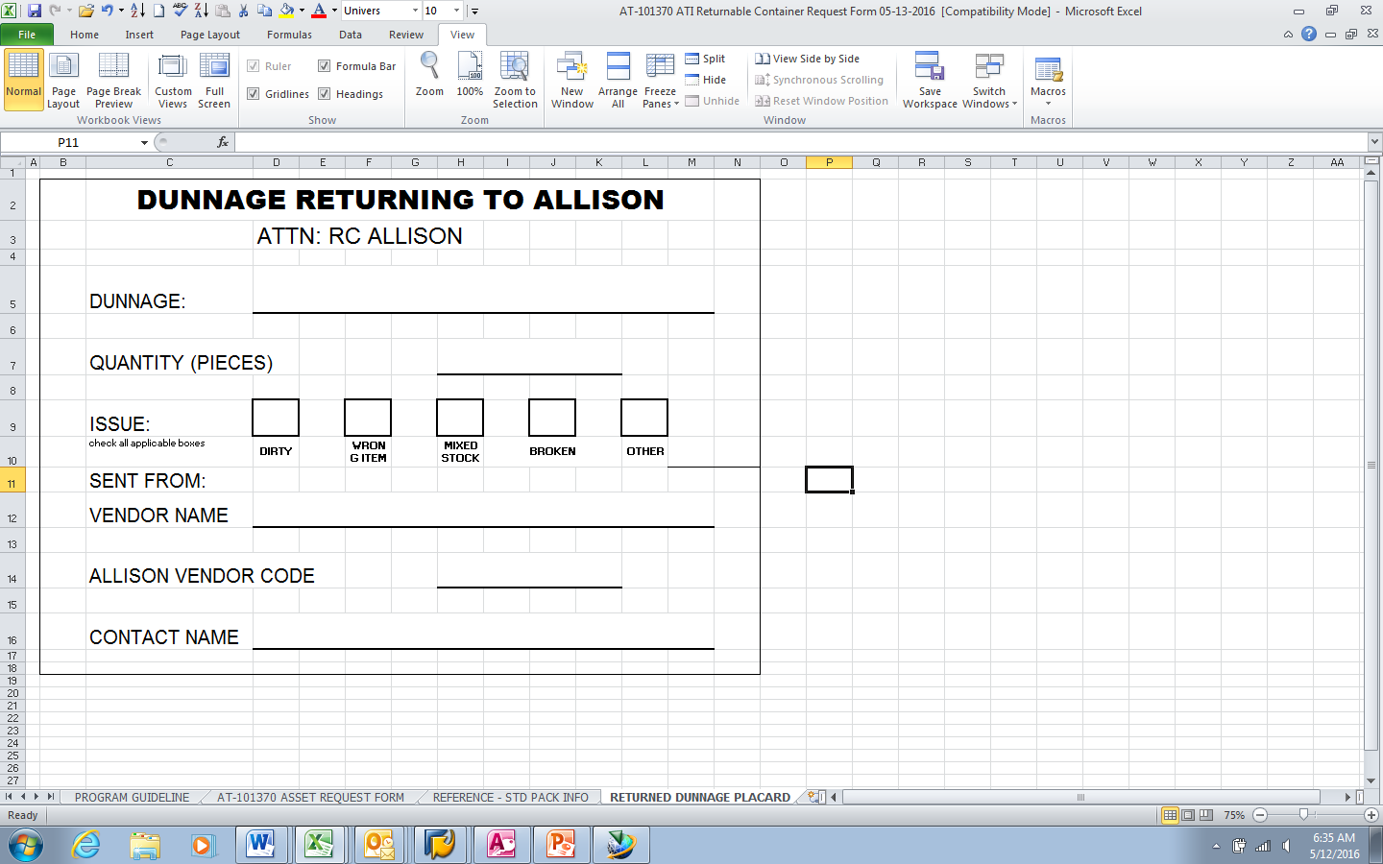

These damaged or dirty assets are to be returned to ATI. They should be sent with an upcoming shipment of components to ATI. These containers, pallets, or layer pads are added to the same shipment bill of lading as any return shipped components as using a separate bill of lading creates a double-shipment on one day which triggers a Transportation Review and might result in a debit to the supplier account.

DAMAGED CONTAINERS DEFINED

A returnable container, by definition, is a multi-use entity and is exposed to harsh environments, blunt force contact, and age and chemical degradation.

ATI makes every effort to remove from service containers and other assets that have been damaged. Some of these can be repaired and others are scrapped.

Any container that does not appear save to load, stack, or move should not be used by a supplier. These should be returned to ATI.

Any layer pad that has metal chips imbedded should not be used. There may be exceptions with some casting dunnage, but for finished machined parts where the chips may damage the parts. Any chip that could injure an operator should also be removed from service.

If there is a minor repair that the supplier can perform-i.e. gate hinge popped out of place, hanging piece of scored plastic on a flat pad, it is requested that the repair be done, and the container or divider used.

DIRTY CONTAINERS DEFINED

ATI will provide containers and dunnage that should be clean and free of debris. Any contamination that occurs at the supplier’s location due to the containers being stored at the supplier’s location is the responsibility of the supplier to clean the containers.

While ATI will provide clean containers and dunnage, it is still the supplier’s responsibility to ensure the container is clean and free from debris prior to placing parts into the container.

It is expected that small, infrequent deviations of cleanliness be fixed at the supplier rather than initiate a formal return. This might include some contamination on top pads created in transit or the missed removal of a prior user’s entire container label.

The Do’s and Don’ts of Packaging for ATI
Poor packaging can destroy the efforts of the supply chain to provide quality components to ATI.
Resources spent at ATI resolving poor packaging efforts impacts ATI customers negatively.
There is going to be some variation in packaging methods used by suppliers especially in dealing with expendable containers and expendable dunnage. The packaging process should be treated as an extension of the manufacturing process with suitable practices and controls to assure delivery of a usable component at ATI.
Therefore, below are examples of actual shipments to ATI that in some cases lack this dedication to proper packaging and in some cases shows a lack of common sense.
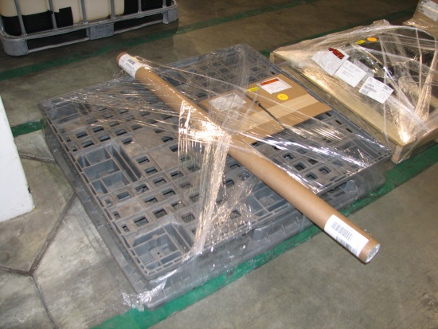
A Don’t…
- Returnable pallets are to be used for our returnable totes.
- Loads should not hang over the edge
- It is very possible this load should have been shipped small package ground instead of Less Than Truckload per our guidelines in the Transportation Routing Instructions.
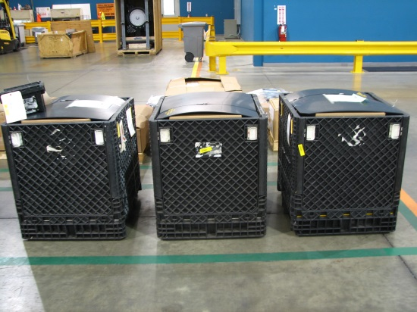
A Don’t…
- Contents of container are over the fill line and containers are no longer stackable.
- Over-tightening of banding that causing arcing s can also cause damage to layer pads.
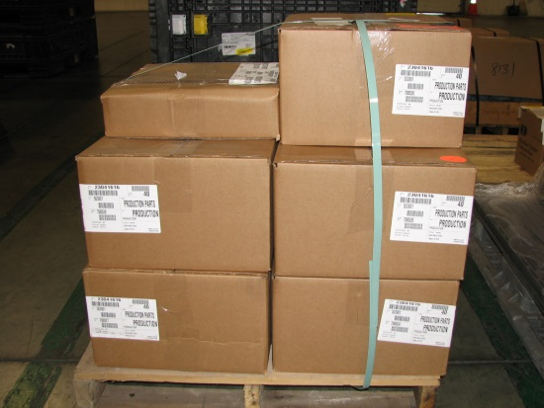
A Don’t…
- Don’t leave banding slack
- Don’t forget to band all containers
- Don’t stack these so they lean over the edge or off the side of the pallet.
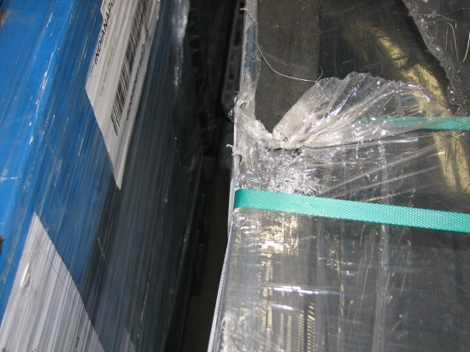
A Don’t…
- Don’t overfill the tote containers
- Totes should always be fully closed
- If the ATI specified pack quantity does not fit, contact the ATI Returnable Container Coordinators.
A Don’t…
- Don’t make banding so tight it distorts the container or digs into the expendable boxes.
- Also, there are banding slots in the containers and banding should never run over the top of the bulk returnable container as this one does.
- See the banding section of this document for guidance on proper banding of ATI returnable bulk containers
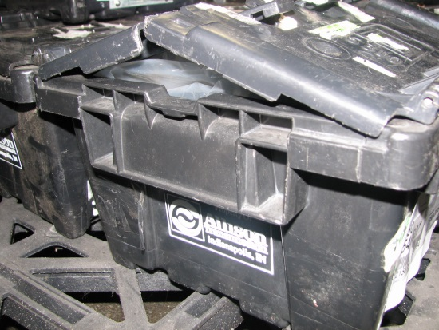
A Do and a Don’t…
- If a returnable tote is shipped via small package ground (e.g. Fed Ex or UPS per our Transportation Routing Instructions), it requires additional security than the snapping closed of the design. Those containers should be banded in this fashion. Banding like this is an option and is preferable over the cable ties shown below.
- The Don’t is Don’t band these totes if they are shipping secured to a pallet shipped via truck.

A Do and a Don’t…
- Don’t use cable ties to secure the container lids unless the container is shipped small package ground to ATI
- These are difficult to remove and when then the tails are trimmed, often sharp edges are created which is a safety issue since they are where the hands go to appropriately handle them.
- Also don’t stick labels where they do not belong.

A Don’t…
- This is a picture of a banded bulk container where the banding straps are several inches above lid.
- Banding is critical to keep parts seated in transit, it isn’t a decoration
- If a load is short, something needs to be added to fill the air gap. That something is not ATI layer pads.
- If a standard pack calls for under packing that would cause this, contact the Returnable Packaging Coordinators for verification and guidance.

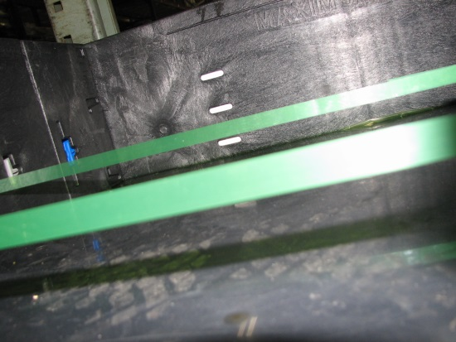

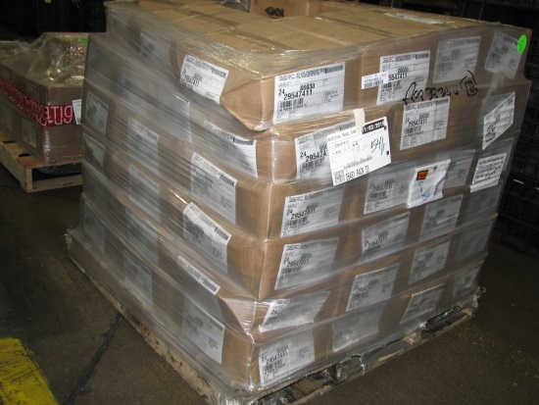
A Don’t…
- Unless approved by ATI, the maximum stack height is less than 42 inches or four tiers of material (three with returnable containers).
- Don’t overfill the tote containers
- This load is overloaded, and the weight of the upper containers is crushing the lower ones. Totes should always be fully closed
- Just don’t do this to save a skid.

Catalogue of Returnable Container Program Assets
Returnable Bulk Box Containers and Banding Guidelines

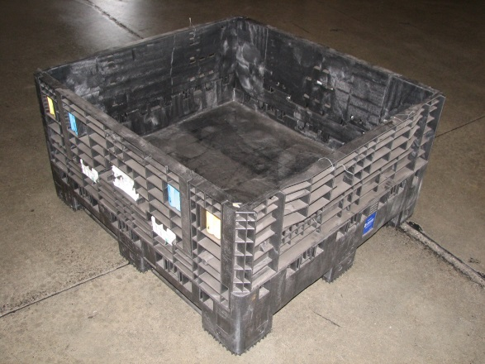
GM5320
- OD: 48” x 45” x 25”
- ID: 44.2” x 41.2” x 19.0”
- Weight: 119.0 lbs.
- Capacity: 1,200 lbs. (including container)
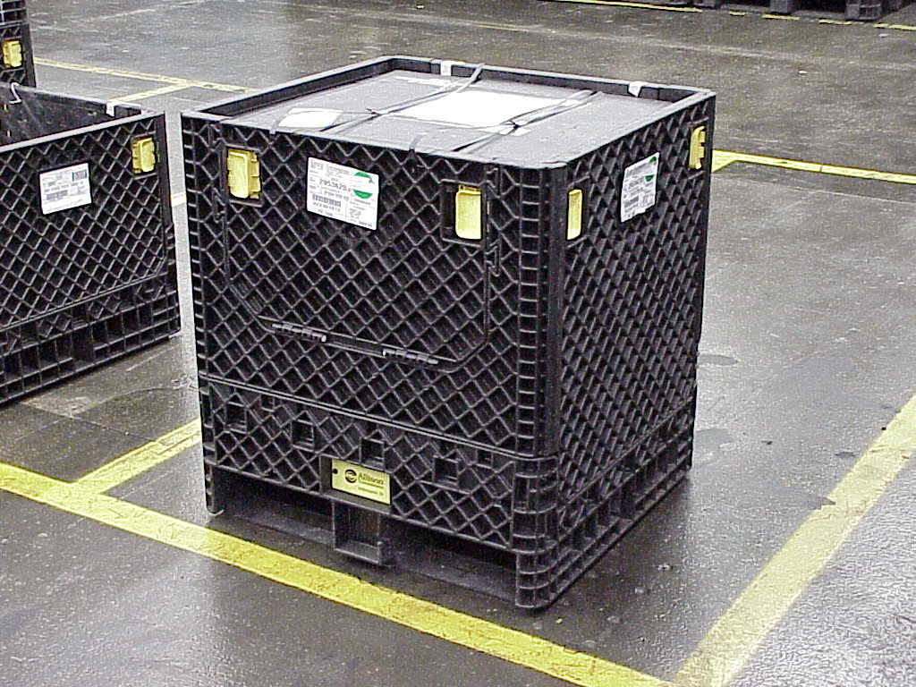
GM5332 (old style)
- OD: 32” x 30” x 34”
- ID: 29.2” x 27.3” x 27.5”
- Weight: 72.0 lbs.
- Capacity: 1,200 lbs. (including container)
- Conveyable base
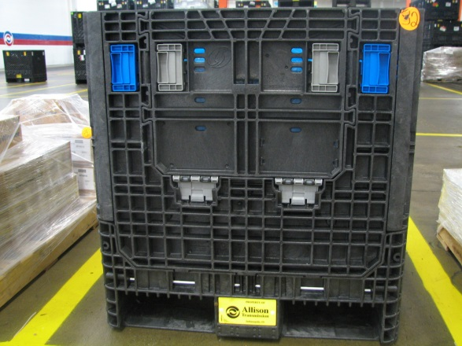
GM5332 (new style)
- OD: 32” x 30” x 34”
- ID: 29.2” x 27.3” x 27.5”
- Weight: 72.0 lbs.
- Capacity: 1,200 lbs. (including container)
- Conveyable base
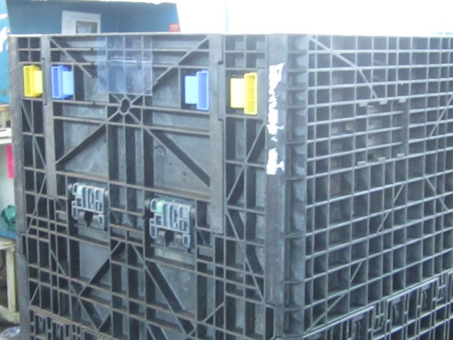
323034-NC
- OD: 32” x 30” x 34”
- ID: 29.2” x 27.3” x 26.5”
- Wei3ght: 78.0 lbs.
- Capacity: 1,200 lbs. (including container)
- Non-conveyable base
- Can be identified by a black Allison Transmission badge at the bottom
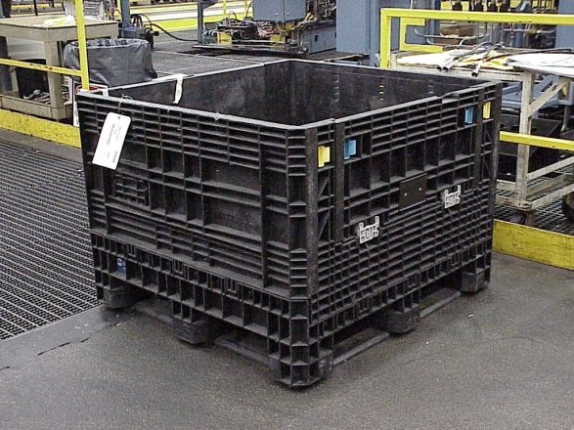
GM5348
- OD: 48” x 45” x 34”
- ID: 44.2” x 41.2” x 27.9”
- Weight: 140.0 lbs.
- Capacity: 1,200 lbs. (including container)
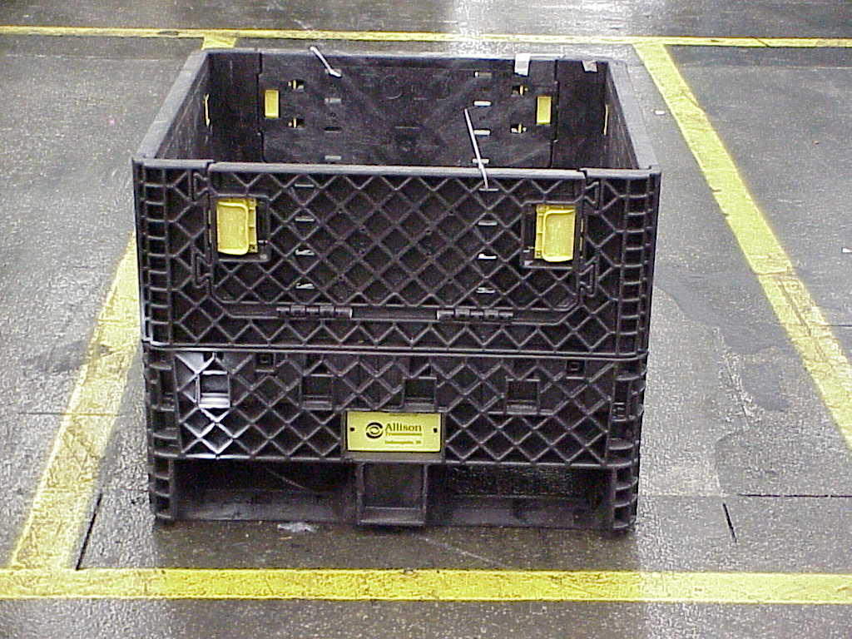
KD323025C
- OD: 32” x 30” x 25”
- ID: 29.2” x 27.3” x 19.0”
- Weight: 65.0 lbs.
- Capacity: 1,200 lbs. (including container)

Banding Bulk Box Containers

Purpose: Banding straps used properly will exert downward pressure on the contents of the container causing the container and its load to become one solid mass. A secured load will be less likely to be susceptible to harmful chatter and vibrations that can be experienced during transit.

Banding Steps:
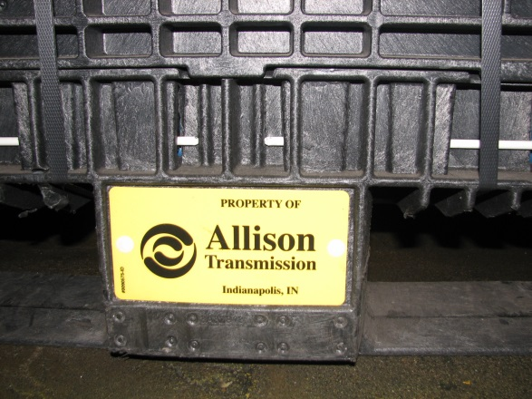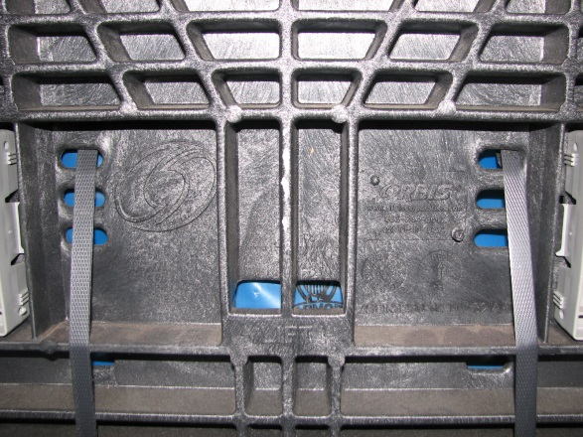
1st step: Bring the band through the pallet front to back on the gate side where the forks go
2nd step: Pull the bands up and thread them through the “banding slots” closest to where the top of the load sits

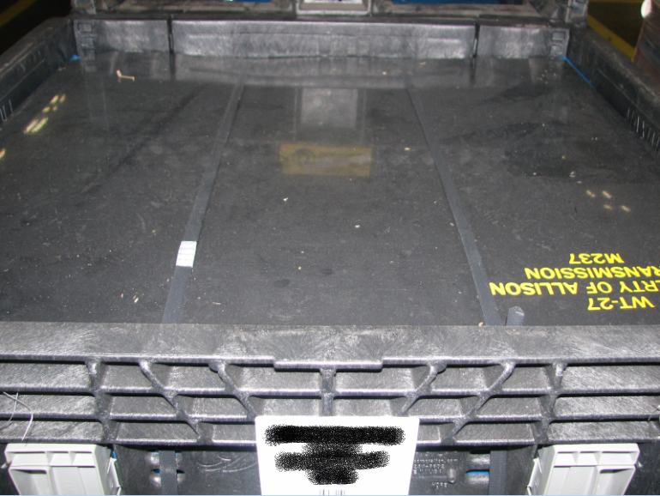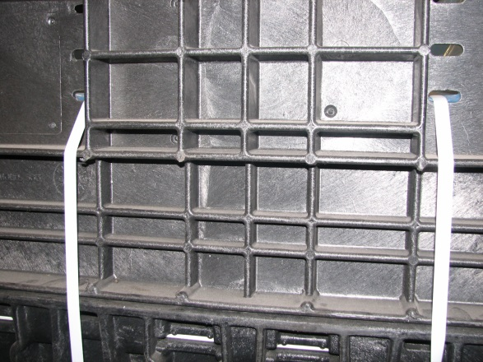
NOTICE!: On larger containers (GM5348 & GM5320 and smaller 323034-NC) bands are to be brought through pallet right to left and banded through “banding slots” on non-gated side
3rd step: Tighten and seal the bands (make sure layer pad is over polybag); Notice bands go through “banding slots” on gate side – Applies to GM5332 and KD323025C

In Summary, the banding should not damage or deform the layer pads or containers. Steel banding should not be used.

Improper Techniques-see photos below

Figure 1: Applying banding in a diagonal fashion in relation to the banding slots above the layer pad.

Figure 2: Leaving any slack in the banding strap that would allow the load to vibrate in transit.

Figure 3: Running banding through anywhere else besides “banding slots” and using more than 2 bands

Figure 4: Make sure bands are in contact with top pad or tray

Figure 5: Do not band over the top of the container

Figure 6: Make sure to band from the bottom of the pallet up and do not only band through slots

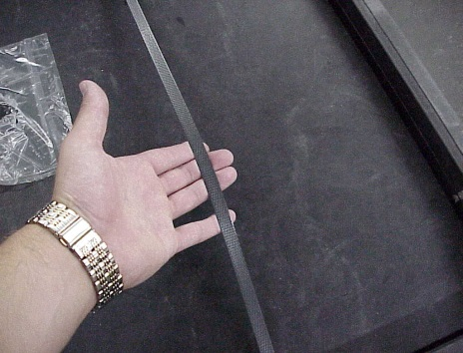
Figure 1

Figure 2

Figure 2

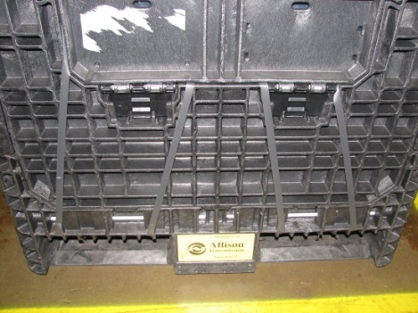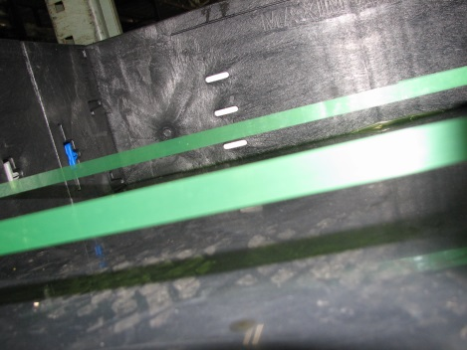
Figure 3

Figure 4

Figure 2
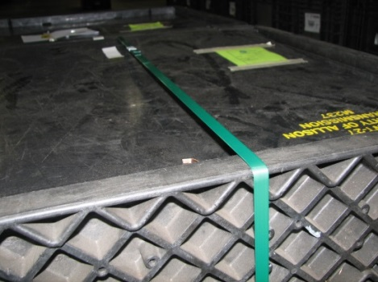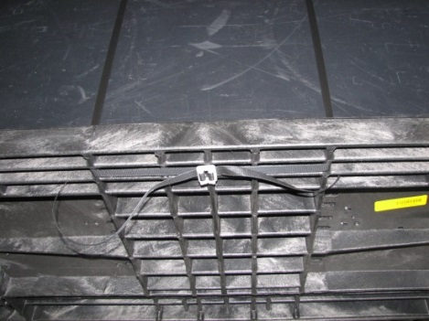
Figure 5

Figure 6

Figure 2

\
Layer Pad Dunnage

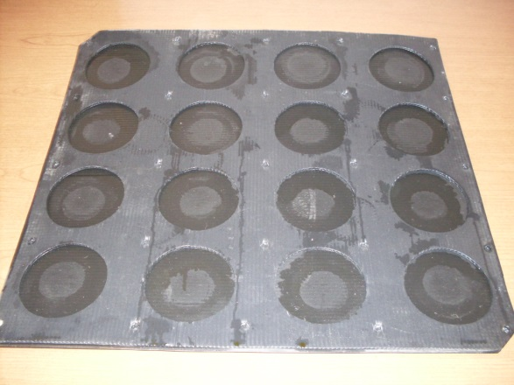
SA-949
- Container: GM5332
- Dimensions: 29.0” x 27.0” x 0.40”
- # of Pockets: 16
- Pocket Diameter: 5.1”
- Weight: 1.6 lbs.
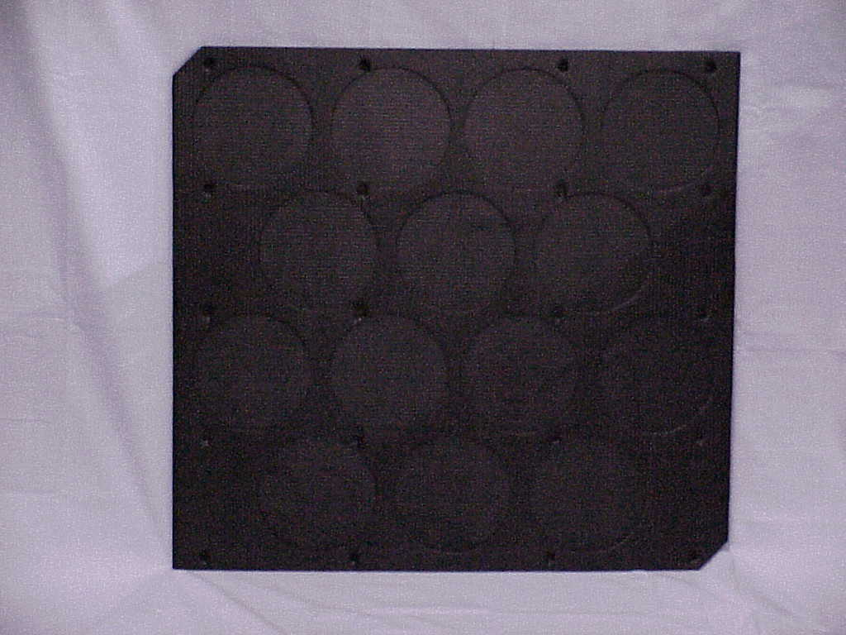
SA-950
- Container: GM5332
- Dimensions: 29.0” x 27.0” x 0.40”
- # of Pockets: 14
- Pocket Diameter: 6.1”
- Weight: 1.6 lbs.
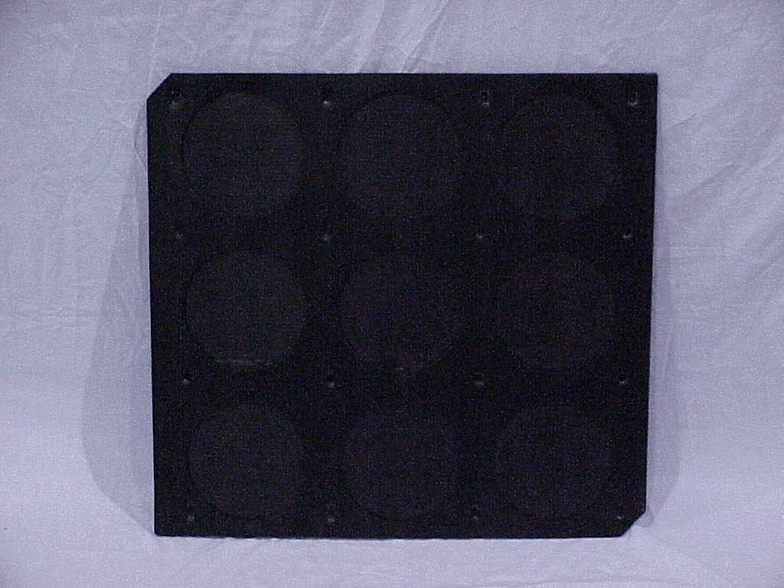
SA-951
- Container: GM5332
- Dimensions: 29.0” x 27.0” x 0.40”
- # of Pockets: 9
- Pocket Diameter: 7.1”
- Weight: 1.7 lbs.
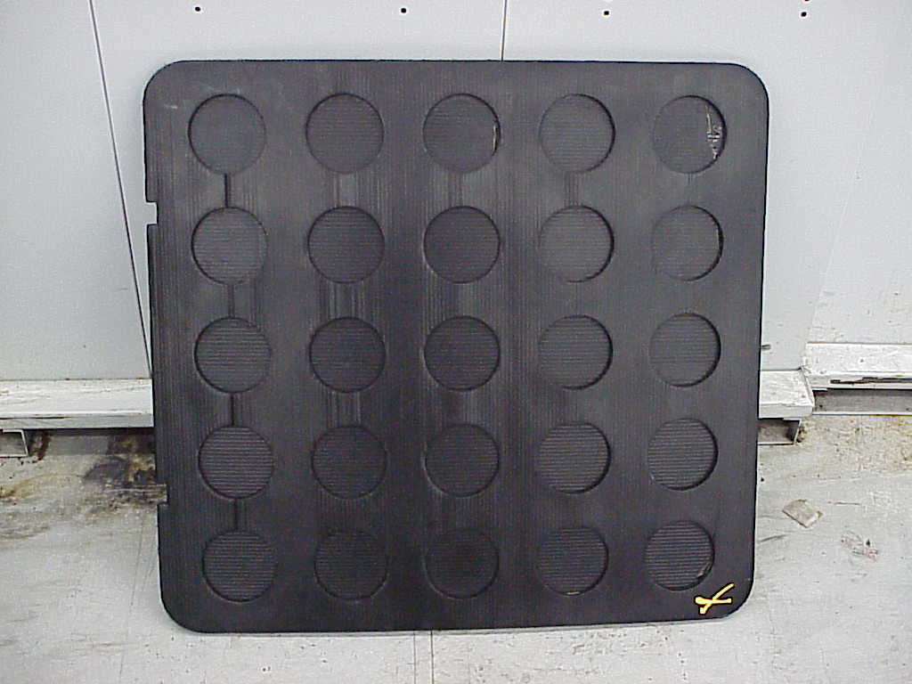
SA-981
- Container: GM5332
- Dimensions: 29.0” x 27.0” x 0.40”
- # of Pockets: 25
- Pocket Diameter: 3.25”
- Weight: 1.6 lbs.
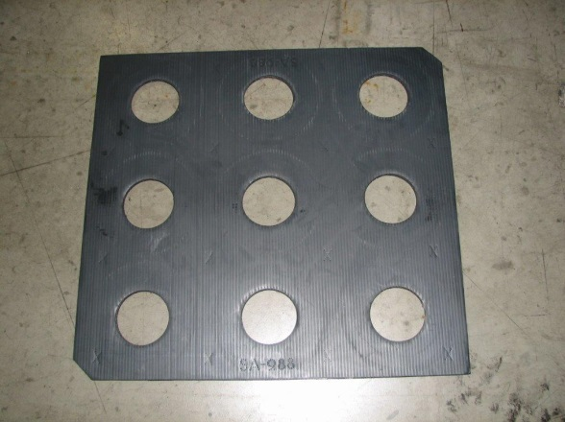
SA-988
- Special 9 – Position Pad
- Container: GM5332
- Dimensions: 28.5” x 26.5” x 0.47”
- # of Pockets: 9
- Pocket Diameter: 4.06”
- Weight: 2.15 lbs.
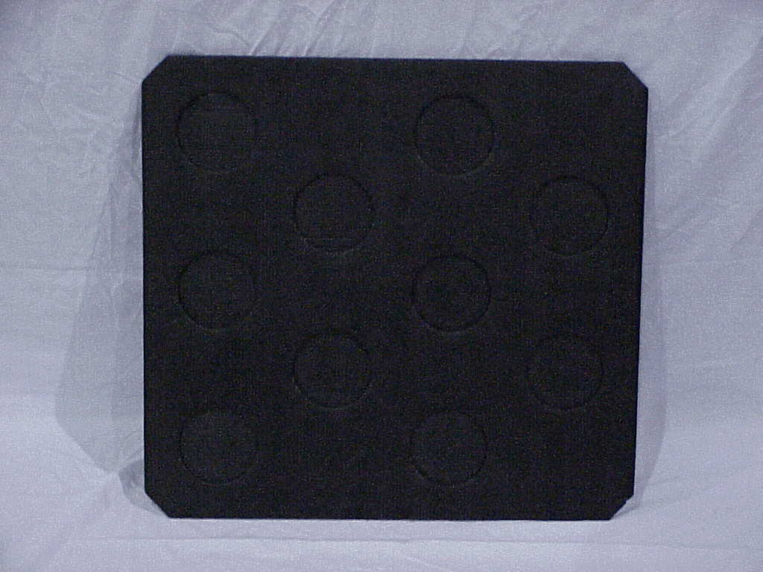
SA-1033
- Special 10 – Position Pad
- Container: GM5332
- Dimensions: 28.5” x 26.5” x 0.40”
- # of Pockets: 10
- Pocket Diameter: 4.5”
- Weight: 3.2 lbs.
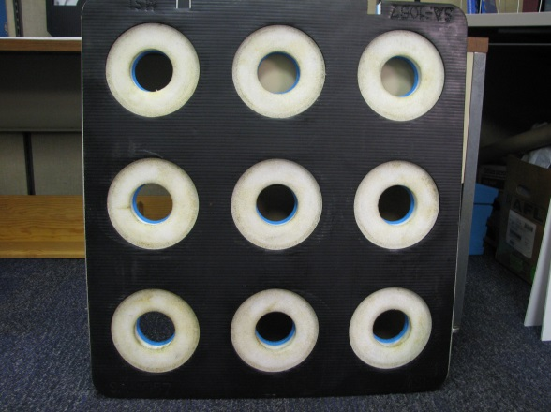
SA-1057
- Special 9 – Position Pad
- Container: GM5332
- Dimensions: 28.5” x 26.75” x 1.5”
- # of Pockets: 9
- Pocket Diameter: 6.52”
- Weight: 4.6 lbs.
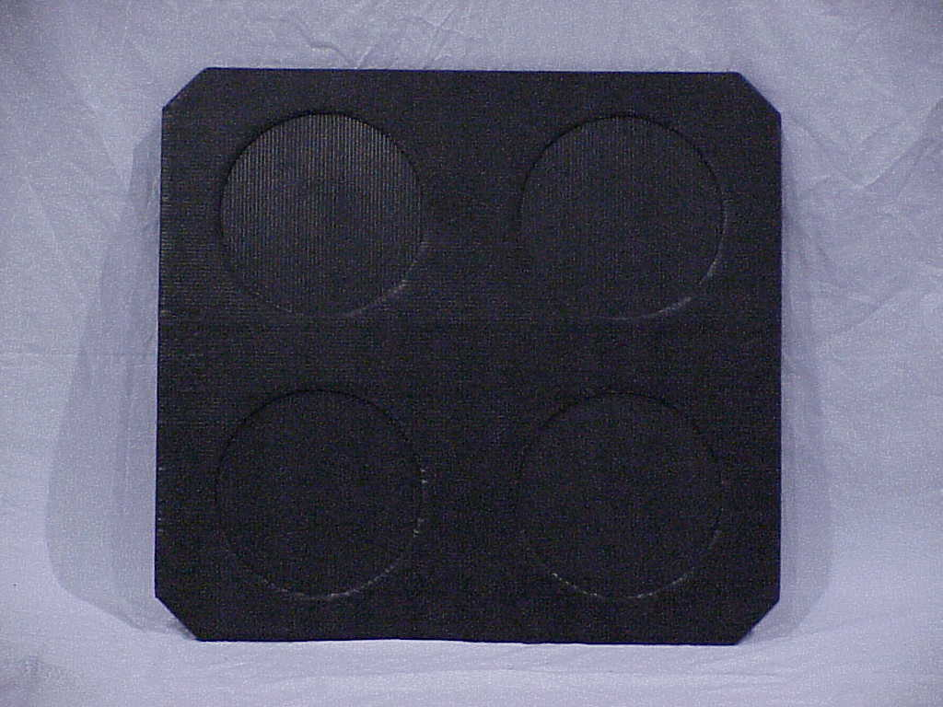
SA-1062
- Container: GM5332
- Dimensions: 29.0” x 27.0” x 0.43”
- # of Pockets: 4
- Pocket Diameter: 9.63”
- Weight: 3.0 lbs.
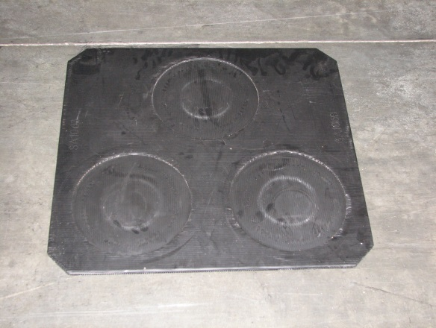
SA-1063
- Container: GM5332
- Dimensions: 29.0” x 27.0” x 0.40”
- # of Pockets: 3
- Pocket Diameter: 11.0”
- Weight: 1.6 lbs.
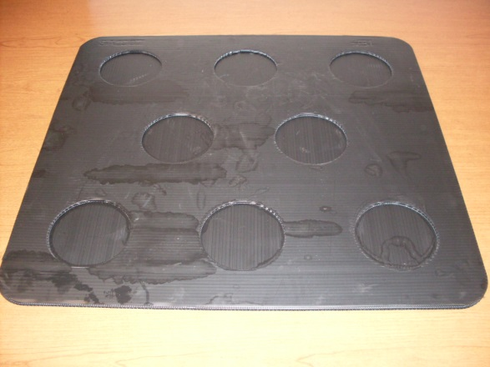
SA-1087
- Container: GM5332
- Dimensions: 29.0” x 27.0” x 0.40”
- # of Pockets: 8
- Pocket Diameter: 5.125”
- Weight: 1.6 lbs.
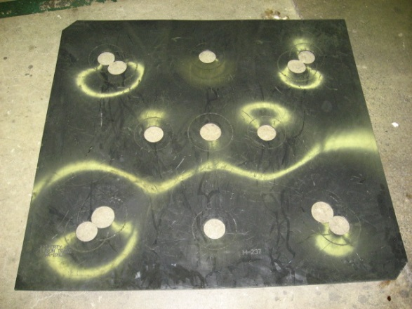
SA-1092
- MD Turbine Cover
- Container: GM5348
- Dimensions: 43.0” x 40.0” x 0.185”
- Weight: 11.0 lbs.
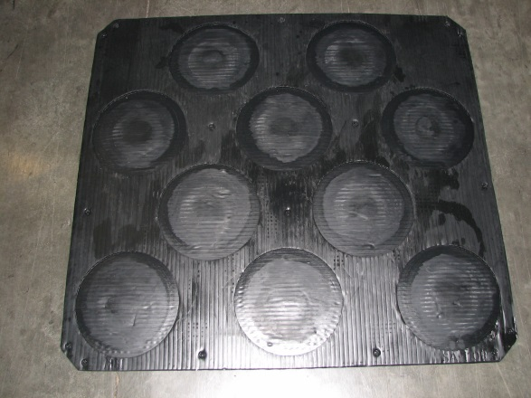
SA-1108
- Container: GM5348
- Dimensions: 43.38” x 40.125” x 0.66”
- # of Pockets: 10
- Pocket Diameter: 10.25”
- Weight: 7.5 lbs.
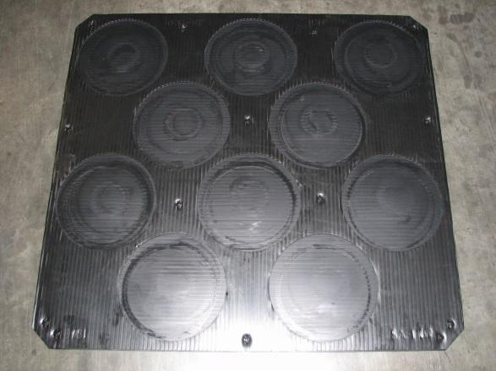
Now used only as backup for SA-1207 & SA-1108
SA-1109
- Container: GM5348
- Dimensions: 43.38” x 40.125” x 1.0”
- # of Pockets: 10
- Pocket Diameter: 11.0”
- Weight: 11.0 lbs.
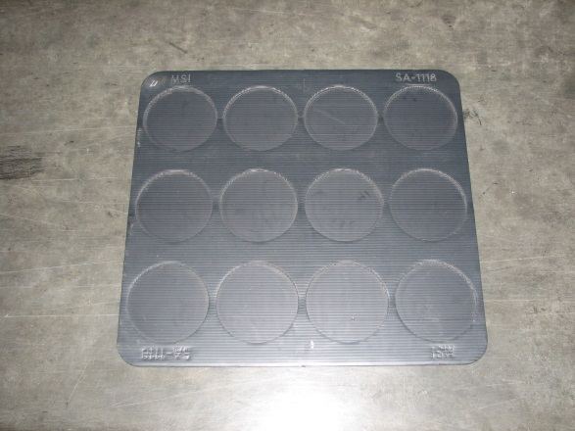
SA-1118
- Container: GM5332
- Dimensions: 29.0” x 27.0” x 0.40”
- # of Pockets: 12
- Pocket Diameter: 6.5”
- Weight: 1.6 lbs.
- Some are all black, some black and white. The black and white are a bit thicker/heavier.
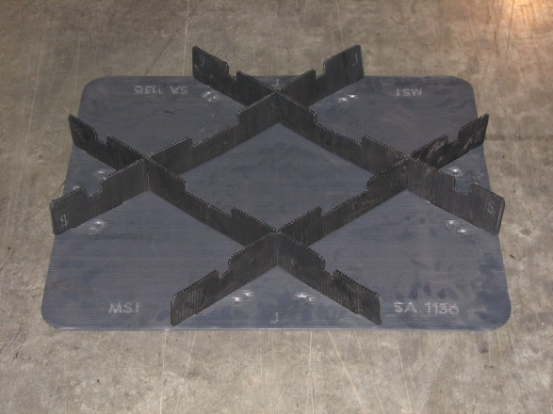
SA-1136
- MD C3/C4 Spring Cell Pack (P/N 29542754 only)
- Container: GM5332
- Dimensions: 29.0” x 27.0” x 3.0”
- # of Pockets: 9
- Pocket Dimensions: 11.0” x 8.0”
- Weight: 2.5 lbs.
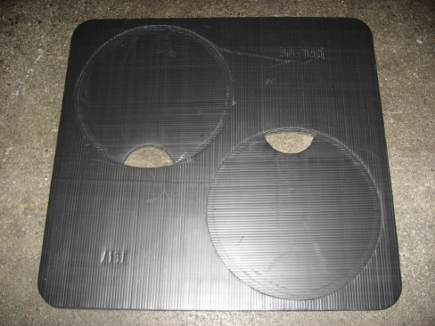
SA-1160
- Container: GM5332
- HD4070 Pistons only
- Dimensions: 29.0” x 27.5” x 0.40”
- # of Pockets: 2
- Pocket Diameter: 14.375”
- Weight: 2.5 lbs.
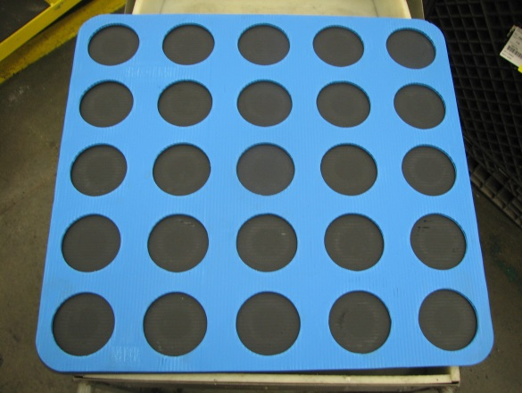
SA-1161
- Container: GM5332
- Dimensions: 29.0” x 27.0” x 0.40”
- # of Pockets: 25
- Pocket Diameter: 4.0”
- Weight: 1.6 lbs.
- Back-up to WT-63
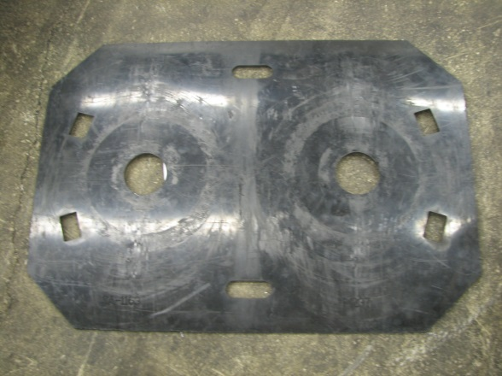
SA-1163
- Top Pad HD Converter Covers Only
- Container: SA-568
- Dimensions: 42.0” x 28.0” x 0.185”
- Weight: 8.0 lbs.
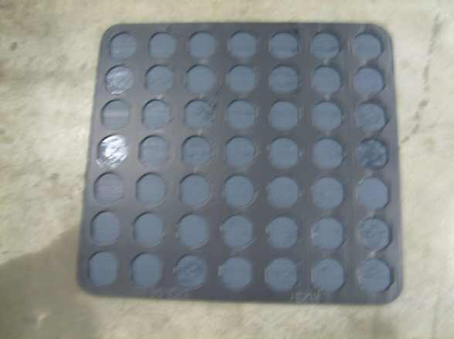
SA-1166
- Container: GM5332
- Dimensions: 28.75” x 26.75” x 0.60”
- # of Pockets: 49
- Pocket Diameter: 3.045”
- Weight: 2.375 lbs.
Top
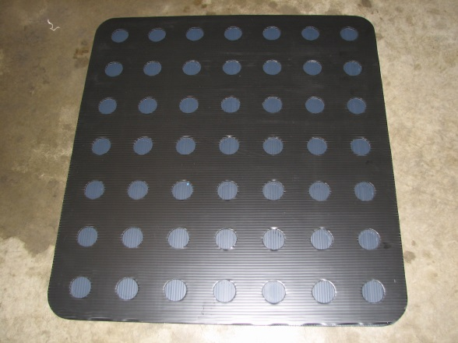
Bottom

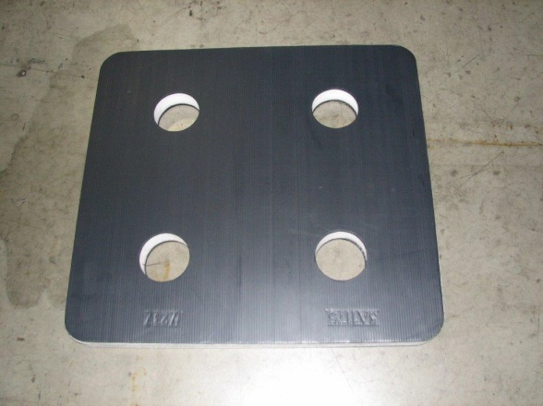
SA-1175
- C6 Clutch Special Layer Pad
- Container: GM5332
- Dimensions: 29.0” x 27.0” x 2.75”
- # of Pockets: 4
- Pocket Diameter: 4.0”
- Weight: 4.0 lbs.
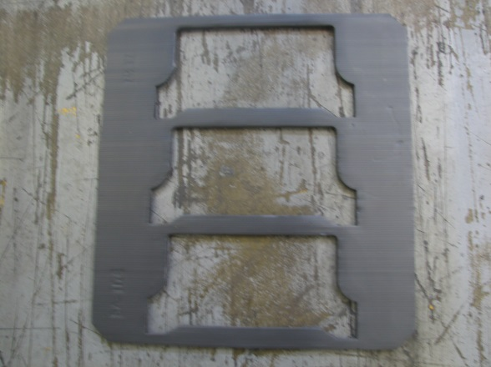
SA-1178
- P/N 29538013 Layer Pad Only
- Container: GM5332
- Dimensions: 28.5” x 26.5” x 0.6”
- # of Pockets: 3
- Pocket Dimensions: 17.18” x 8.375”
- Weight: 2.375 lbs.
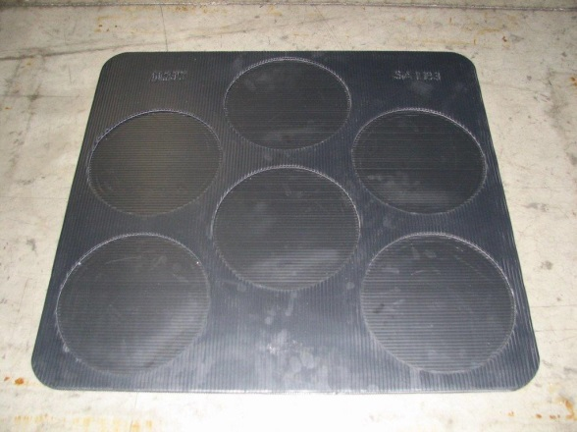
SA-1183
- Container: GM5332
- Dimensions: 28.75” x 26.75” x 0.4”
- # of Pockets: 6
- Pocket Diameter: 9.13”
- Weight: 1.5 lbs.
- MD C3/C4 pistons only
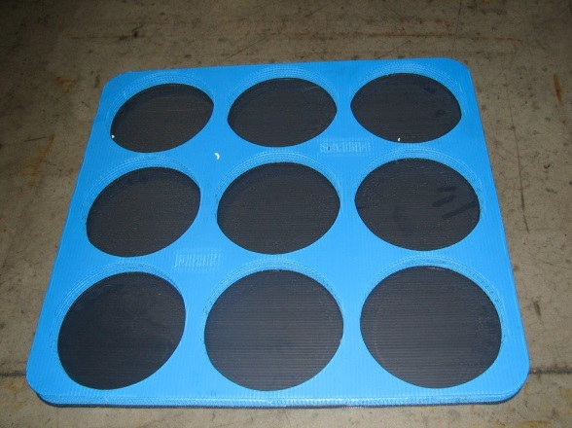
SA-1184
- Color: Black and Blue
- Container: GM5332
- Dimensions: 29.0” x 27.0” x 1.4”
- # of Pockets: 9
- Pocket Diameter: 8.4”
- Weight: 5.5 lbs.
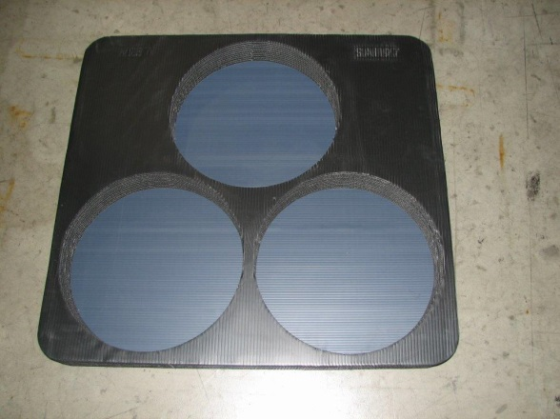
SA-1197
- Container: GM5332
- Dimensions: 28.75” x 26.75” x 2.25”
- # of Pockets: 3
- Pocket Diameter: 13.0”
- Weight: 10.125 lbs.
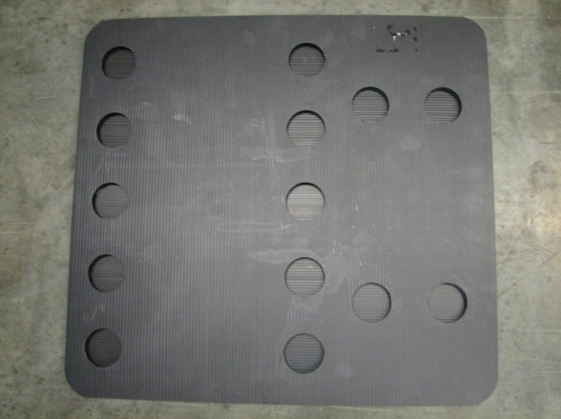
SA-1198
- WT Cooler Special Layer Pad
- Container: GM5332
- Dimensions: 28.75” x 26.75” x 0.67”
- Pocket Diameter: 2.56”
- Weight: 3.0 lbs.
- Holds 7 coolers per layer
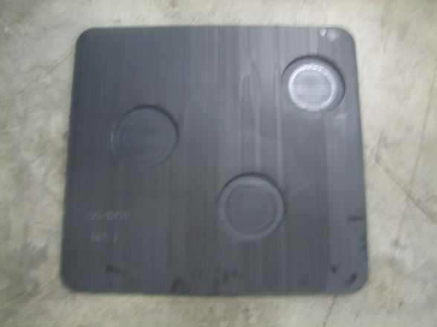
SA-1201
- TC-10 Retainer Special Layer Pad
- Container: GM5332
- Dimensions: 28.75” x 26.75” x 0.60”
- Pocket Diameter: 6.3”
- Weight: 3.2 lbs.


WT-27
- Container: GM5332
- Dimensions: 29.0” x 27.0” x 0.1875”
- Weight: 4.75 lbs.
- Flat pad-no pockets

WT-28
- Container: GM5348
- Dimensions: 44.0” x 41.0” x 0.15”
- Weight: 11.5 lbs.
- Flat pad-no pockets
- Some older pads are .1875” thick
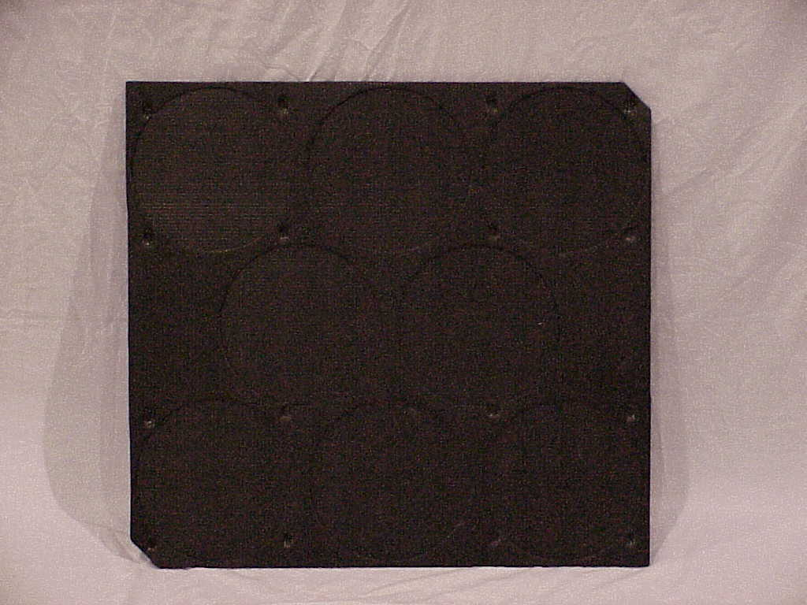
WT-54
- Container: GM5332
- Dimensions: 29.0” x 27.0” x 0.40”
- # of Pockets: 8
- Pocket Diameter: 9.0”
- Weight: 1.6 lbs.
- Cannot be used as back-up for WT-56
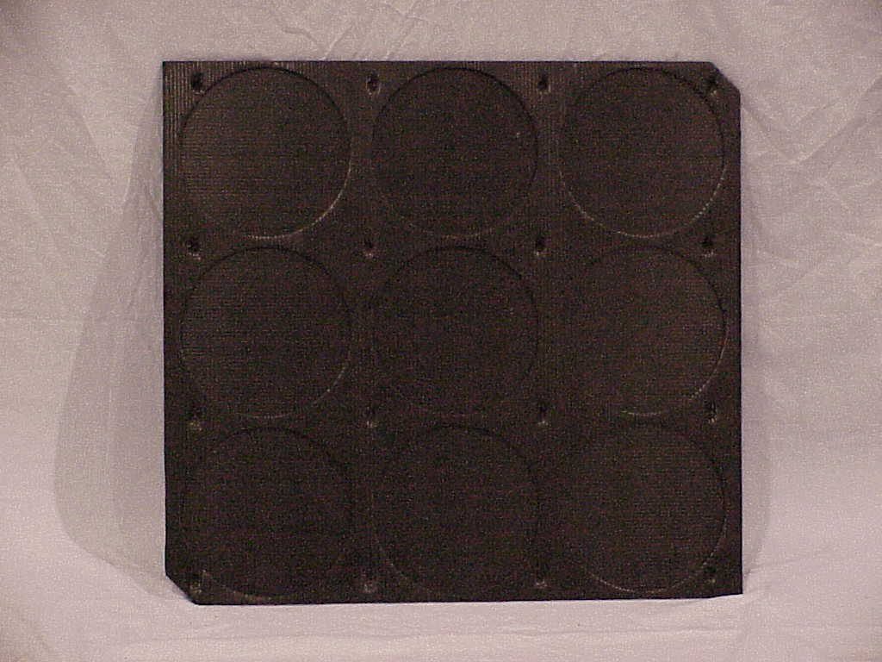
WT-55
- Container: GM5332
- Dimensions: 29.0” x 27.0” x 0.40”
- # of Pockets: 9
- Pocket Diameter: 8.4”
- Weight: 1.6 lbs.
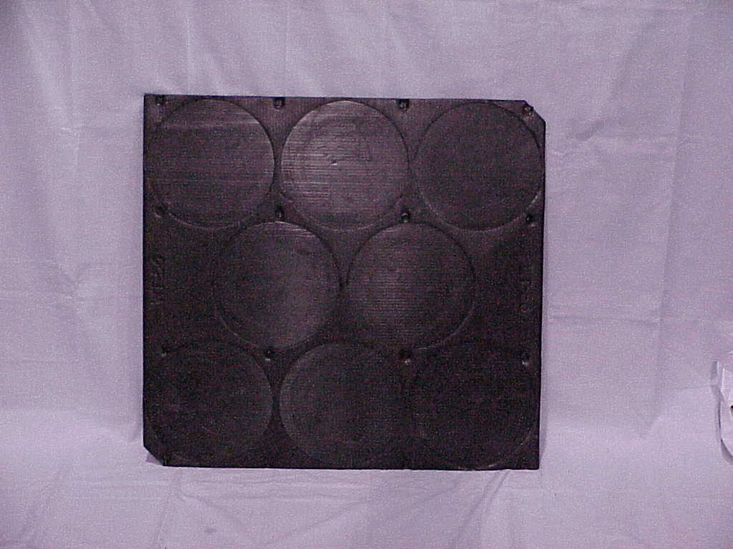
WT-56
- Container: GM5332
- Dimensions: 29.0” x 27.0” x 0.40”
- # of Pockets: 8
- Pocket Diameter: 9.125”
- Weight: 1.6 lbs.
- Often used as a back-up for WT-54
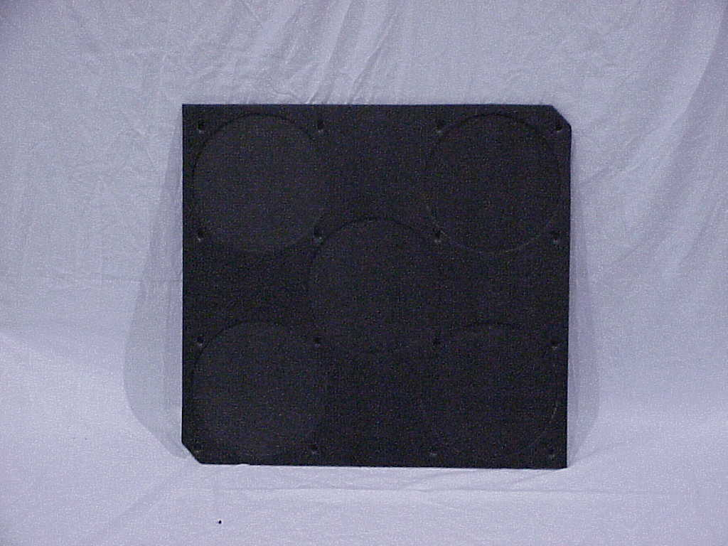
WT-58
- Container: GM5332
- Dimensions: 29.0” x 27.0” x 0.40”
- # of Pockets: 5
- Pocket Diameter: 10.125”
- Weight: 1.6 lbs.
- Often used as a back-up for WT-67
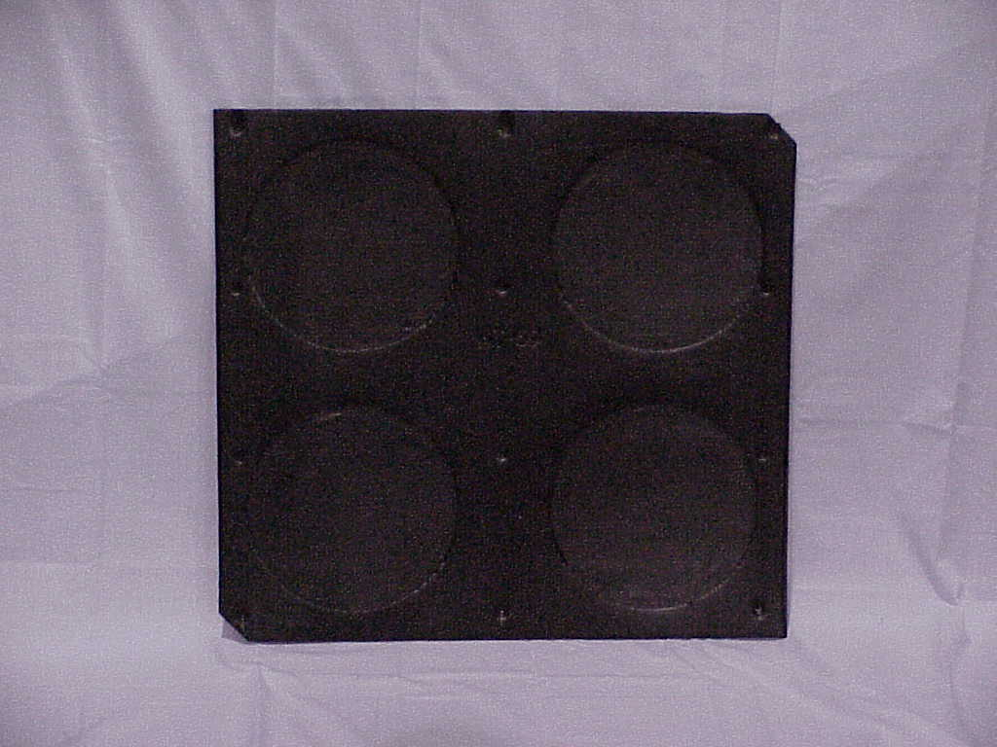
WT-59
- Container: GM5332
- Dimensions: 29.0” x 27.0” x 0.40”
- # of Pockets: 4
- Pocket Diameter: 10.5”
- Weight: 1.6 lbs.
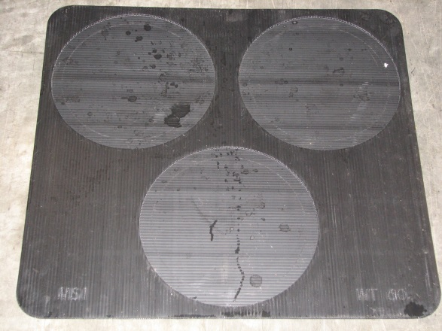
WT-60
- Container: GM5332
- Dimensions: 29.0” x 27.0” x 0.40”
- # of Pockets: 3
- Pocket Diameter: 12.7”
- Weight: 1.6 lbs.
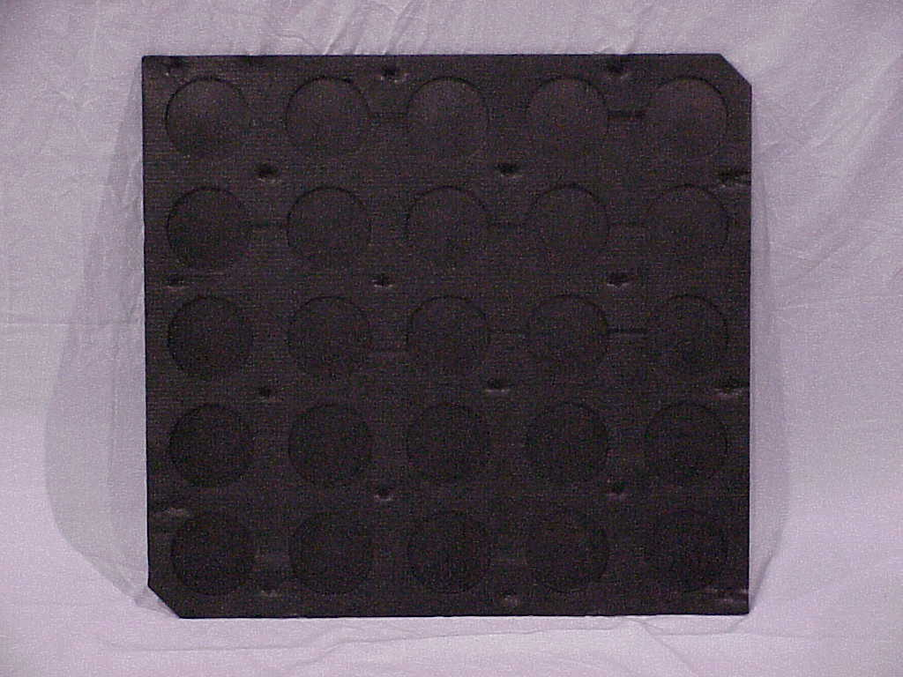
WT-63
- Container: GM5332
- Dimensions: 29.0” x 27.0” x 0.40”
- # of Pockets: 25
- Pocket Diameter: 4.0”
- Weight: 1.6 lbs.
- SA-1161 is similar and may be used as a back-up
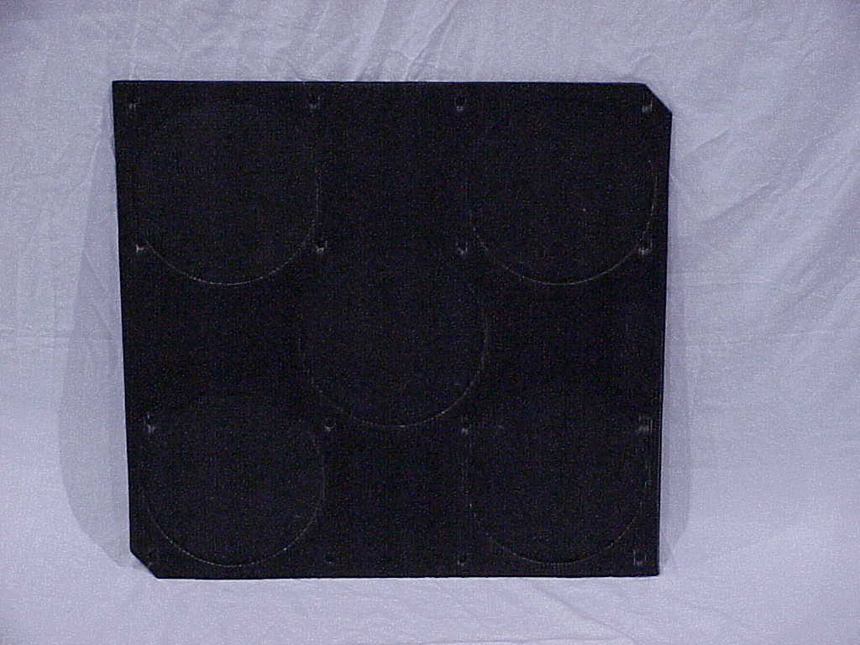
WT-67
- Container: GM5332
- Dimensions: 29.0” x 27.0” x 0.40”
- # of Pockets: 5
- Pocket Diameter: 9.75”
- Weight: 1.6 lbs.

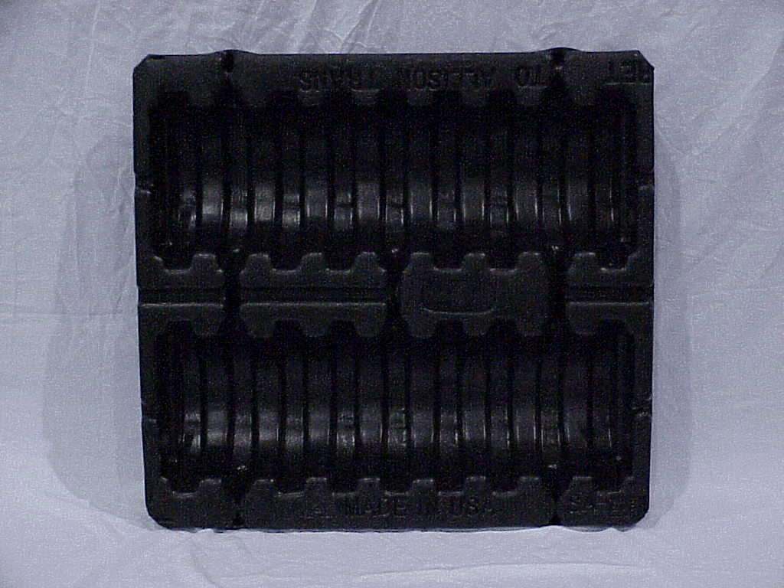
SA-978
- LCT Clutch Pack C4/C5
- Container: GM5332
- Dimensions: 28.75” x 26.75” x 4.75”
- # of Pockets: 18
- Pocket Size: 10.0” x 1.5” x 4.5”
- Weight: 7.3 lbs.
- Tooling now at ProForm Plastics
Tray Dunnage

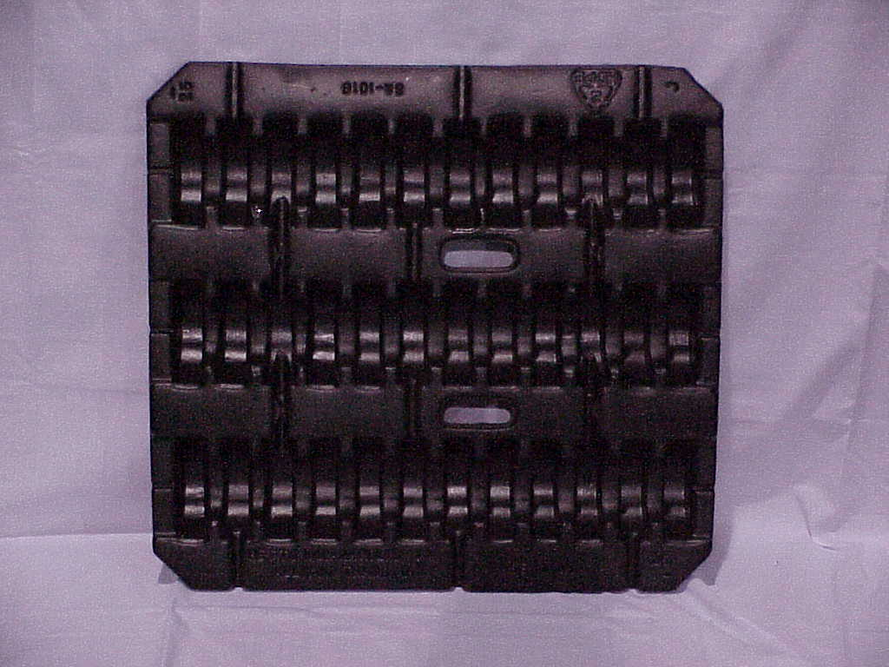
SA-1016
- LCT Clutch Pack C1
- Container: GM5332
- Dimensions: 28.75” x 26.75” x 4.75”
- # of Pockets: 36
- Pocket Size: 5.5” x 1.5” x 2.0”
- Weight: 7.3 lbs.
- Tooling now at ProForm Plastics
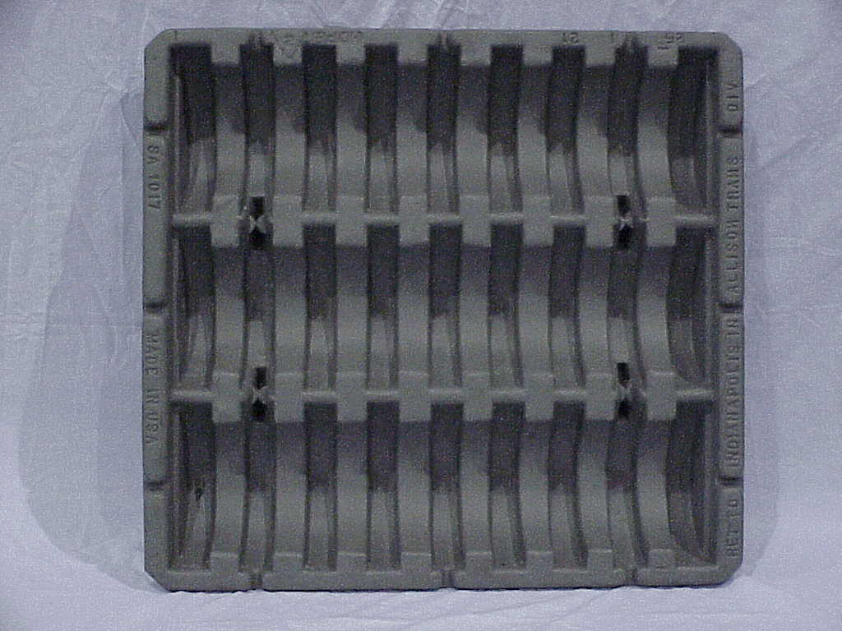
SA-1017
- LCT Clutch Pack C2
- Container: GM5332
- Dimensions: 29.0” x 27.0” x 4.5”
- # of Pockets: 27
- Pocket Size: 8.0” x 1.5” x 3.0”
- Weight: 7.3 lbs.
- Tooling now at ProForm Plastics
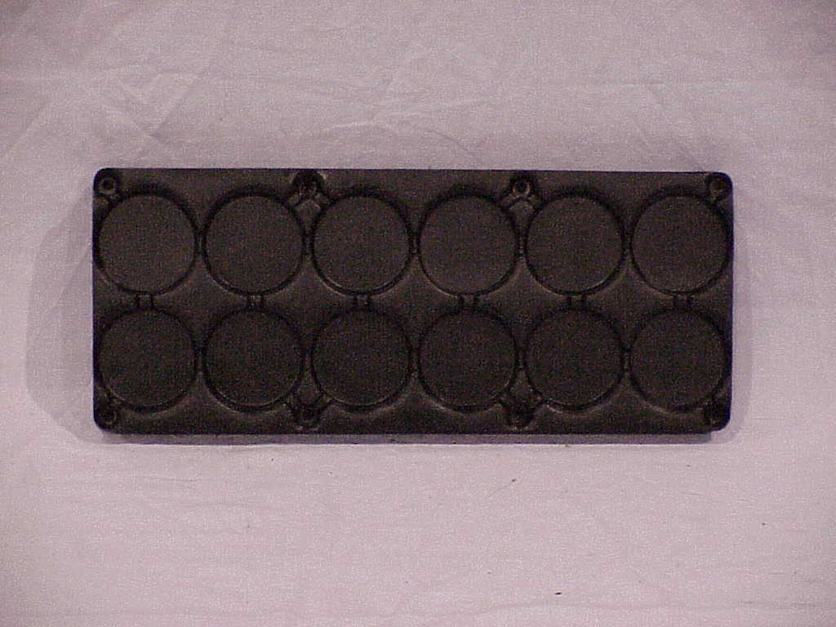
Now used as backup for SA-1206
SA-1030
- LCT Filter Tray
- Container: GM5314
- Dimensions: 19.88” x 8.2” x 0.7”
- # of Pockets: 12
- Pocket Diameter: 3.0”
- Weight: 0.86 lbs.
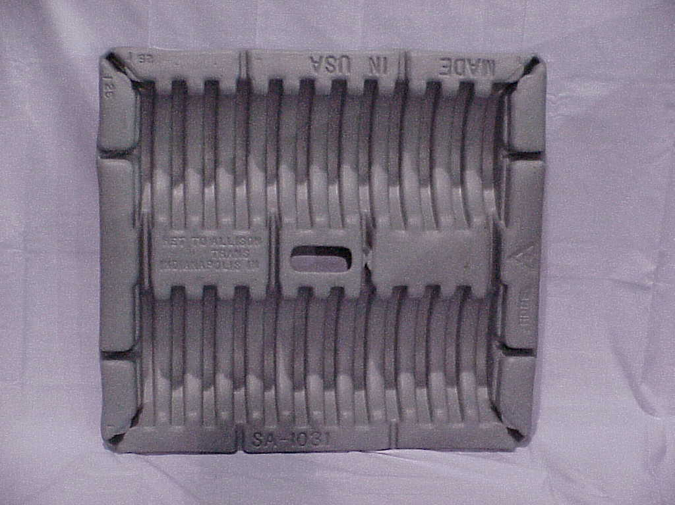
SA-1031
- LCT Clutch Pack C3
- Container: GM5332
- Dimensions: 28.75” x 26.75” x 2.75”
- # of Pockets: 24
- Pocket Size: 9” x 1” x 5”
- Weight: 7.3 lbs.
- Tooling at ProForm Plastics
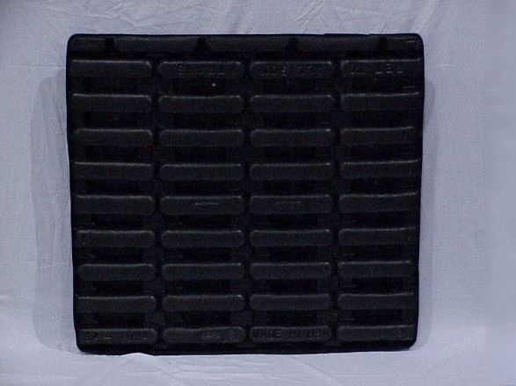
SA-1034
- LCT Front Support Divider
- Container: GM5348
- Dimensions: 44.0” x 41.0” x 4.0”
- # of Pockets: 32
- Pocket Size: 6” x 2” x 2.5”
- Weight: 14.85 lbs.
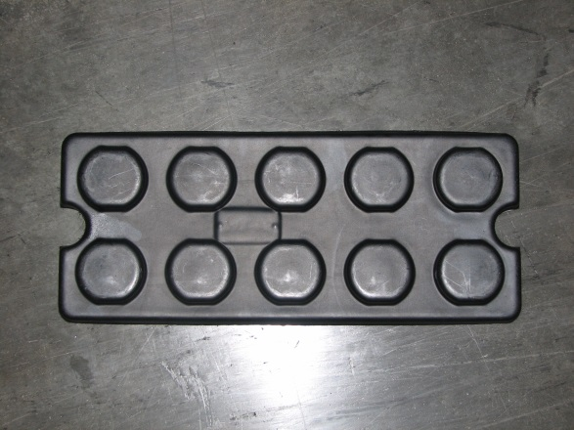
SA-1066
- Tray Tone Wheel
- Container: GM5314
- Dimensions: 20.5” x 8.5” x 1.5”
- # of Pockets: 10
- Pocket Diameter: 2.75”
- Weight: .86 lbs.
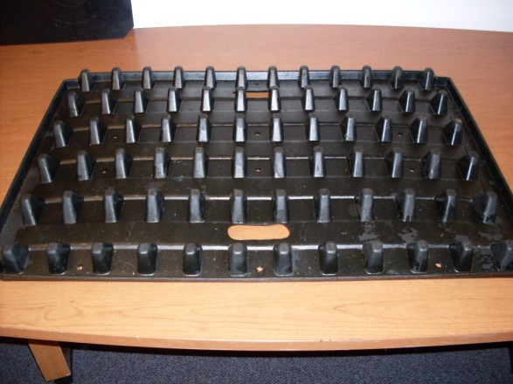
SA-1089
- Shaft Divider MD/HD
- Container: SA-568
- Dimensions: 40.0” x 32.0” x 3.0”
- Weight: 12.0 lbs.
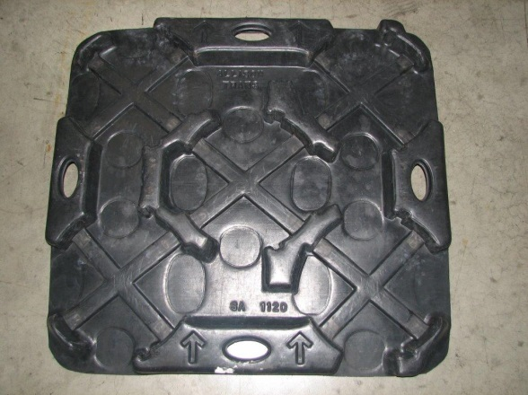
SA-1120
- MD C3/C4 Clutch Tray
- Container: GM5332
- Dimensions: 28.0” x 25.0” x 3.0”
- # of Pockets: 5
- Weight: 6.0 lbs.
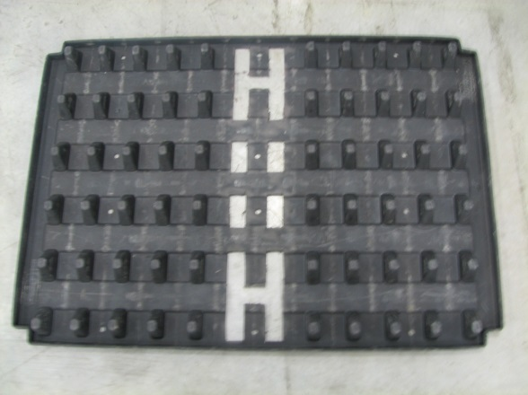
SA-1185
- SA-1089 with 2 center rows of tabs cut out
- TC-10 Turbine Shaft only
- Some have a faint orange stripe at the bottom
- Container: GM5348
- Dimensions: 40.0” x 32.0” x 3.0”
- Weight: 11.8 lbs.

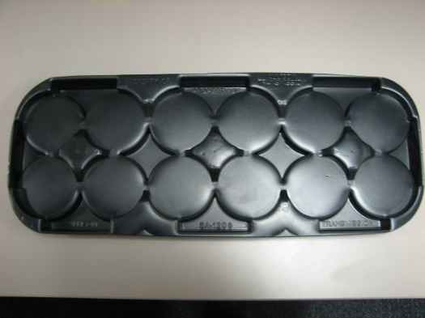
SA-1206
- LCT Filter Tray
- Color: Black w/ Blue Stripe on bottom
- Container: GM5314
- Dimensions: 19.8” x 7.47” x 1.2”
- # of Pockets: 12
- Pocket Diameter: 3.0”
- Weight: 0.70 lbs.
- SA-1030 can serve as a back-up to this divider
Top
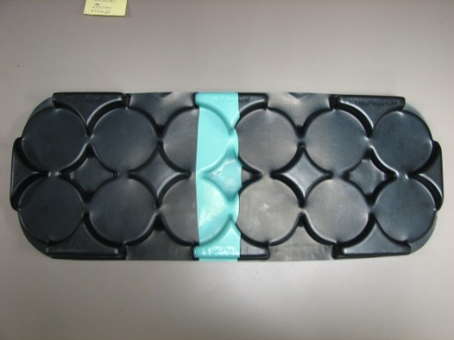
Bottom SA-1206

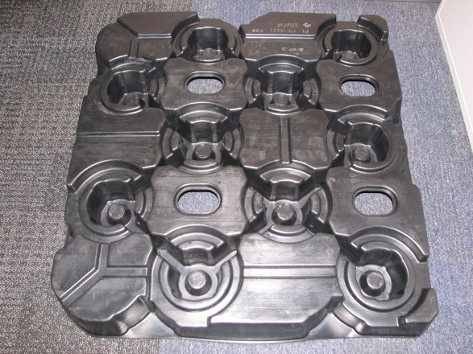

SA-1207
- P2/P3 HD Carrier Tray
- Color: Black
- Container: GM5348
- Dimensions: 43.9” x 40.9” x 4.88”
- Pocket Diameter: 4.05”
- Weight: 16.16 lbs.
Top
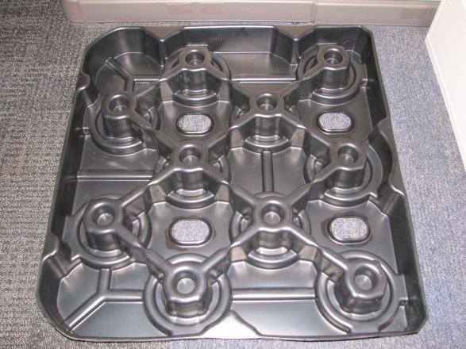
Bottom
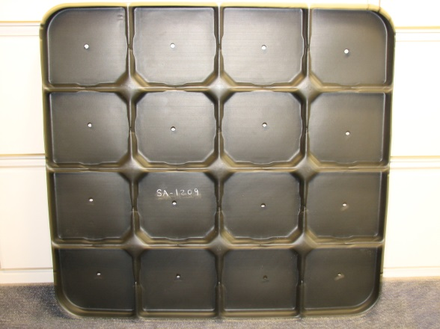
SA-1209
- Tray
- Container: GM5332
- Dimensions: 29.25” x 27.25” x 1.25”
- # of Pockets: 16
- Pocket Size: 6.72” x 6.37” x 1.25”
- Weight: 4.09 lbs.
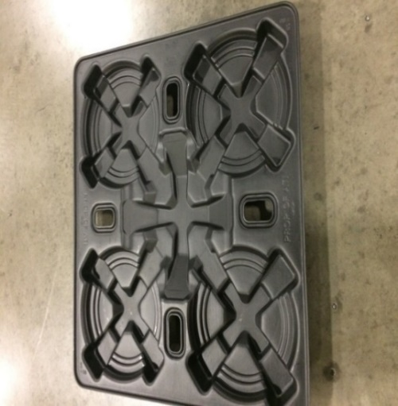
SA-1214
- HD/MD Torque Converter divider
- Container: GM5348 –
- 20 per container
- Dimensions: 44.125” x 41” x 4”
- # of pockets 4 HD / 5 MD
- Pocket Diameter: 19.5
- Weight: 10.
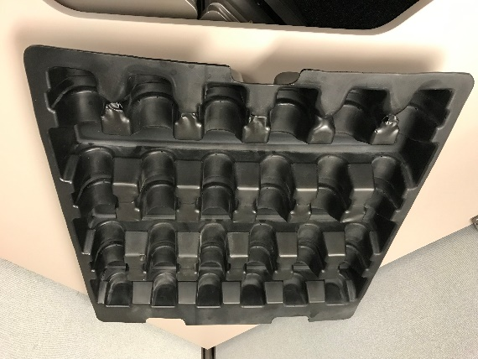
SA-1225
- Tray
- Container: GM5332
- Dimensions: 29” x 27” x 3.65”
- # of Pockets: 18
- Pocket Size: 7” x 2.75” x 2.625”
- Weight: lbs.
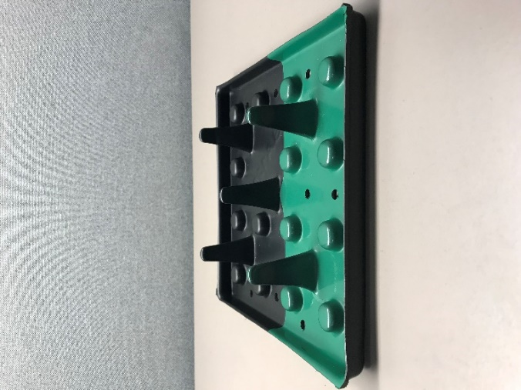
SA-1226
- Tray
- Container: GM5332
- Dimensions: 8.2” x 8.2” x 1.8”
- # of Pockets: 15
- Weight: 0.295 lbs.
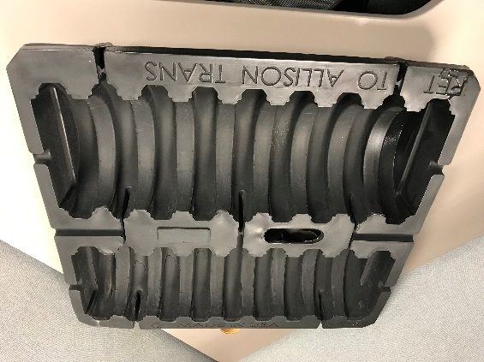
SA-1231
- MD9 Clutch Pack C5/C6
- Container: GM5332
- Color: Black
- Dimensions: 29.0” x 27.0” x 5.08”
- # of Pockets: 18
- Weight: 5.51 lbs.
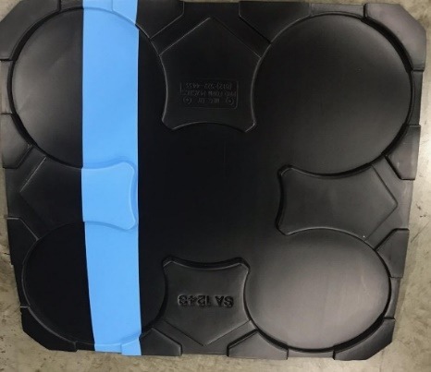
SA-1243
- HD Ring Gear Tray
- Container: GM5332
- Color: Black - Blue Stripe
- Dimensions: 28.75” x 26.75” x 0.75”
- # of Pockets: 5==part placement 10.76
- Weight: 3.5

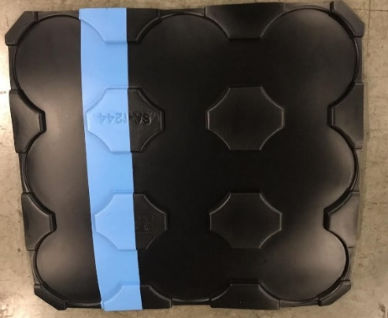
SA-1244
- MD Ring Gear Tray
- Container: GM5332
- Color: Black – Blue Stripe
- Dimensions: 28.75” x 26.75” x 0.75”
- # of Pockets: 9==part placement 7.6
- Weight:3.5

SA-1250
- MD Ring Gear Tray
- Container: GM5332
- Color: Black – Green Stripe
- Dimensions: 28.75” x 26.75” x 0.75”
- # of Pockets: 16==part placement 6.51
- Weight:3.5
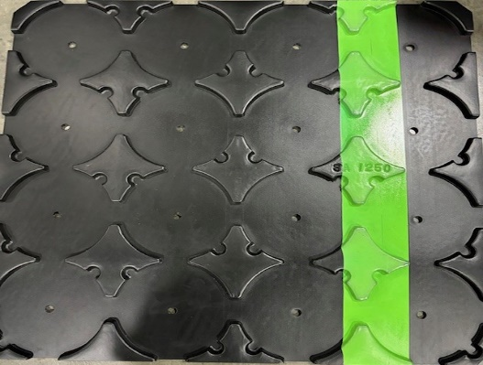

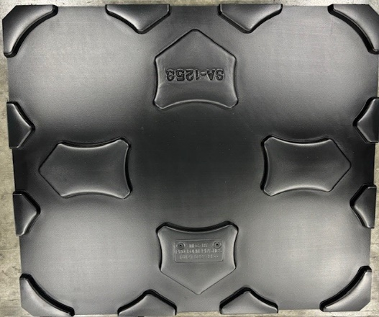
SA-1253
- HD Ring Gear Tray
- Container: GM5332
- Color: Black –NO STRIPE
- Dimensions: 28.75” x 26.75” x 0.75”
- # of Pockets: 5==part placement 10.76
- Weight:
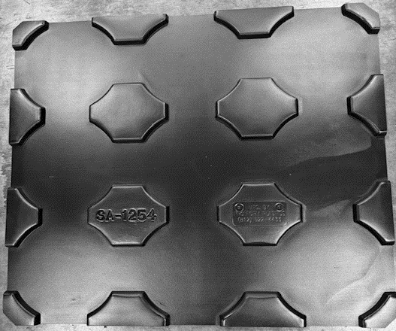
SA-1254
- MD Ring Gear Tray
- Container: GM5332
- Color: Black –NO STRIPE
- Dimensions: 28.75” x 26.75” x 0.75”
- # of Pockets: 9==part placement 7.6
- Weight:

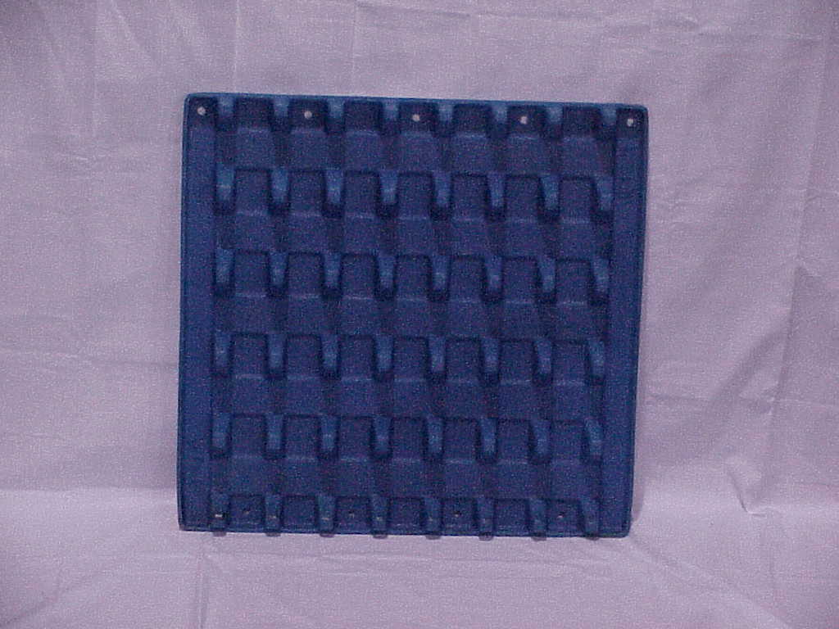
WT-03
- Shaft/Sleeve Tray
- Container: GM5332
- Color: Black or Blue
- Dimensions: 29.0” x 27.0” x 3.0”
- # of Pockets: 35
- Weight: 5.51 lbs.
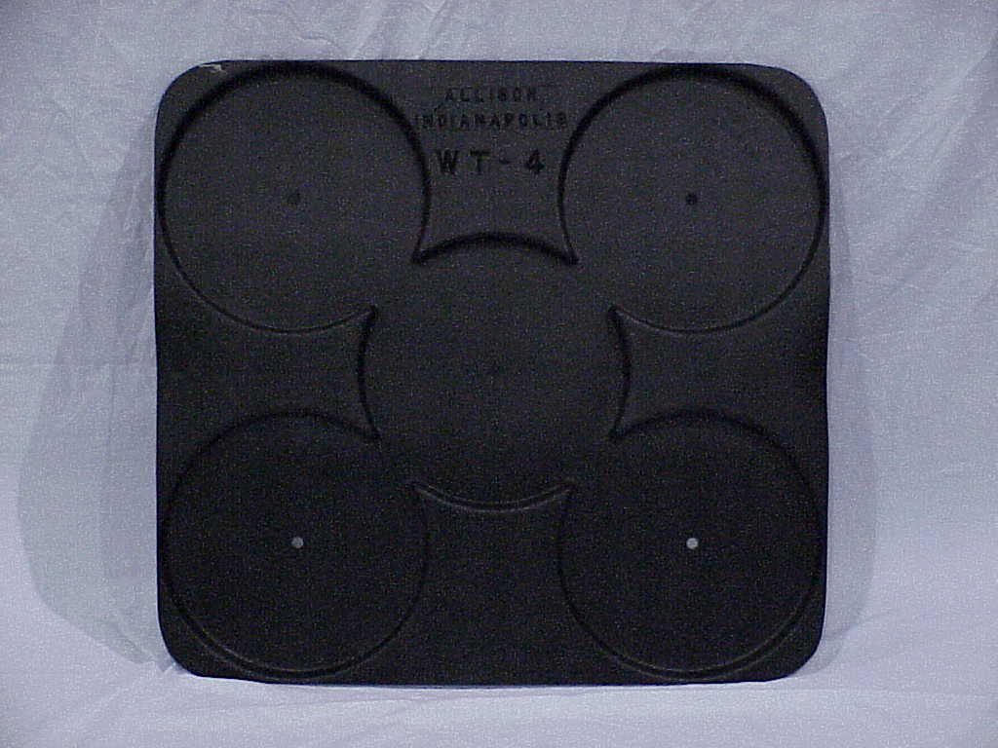
WT-04
- Tray
- Container: GM5332
- Dimensions: 29.0” x 27.0” x 1.0”
- # of Pockets: 5
- Pocket Diameter: 11.5”
- Weight: 5.08 lbs.
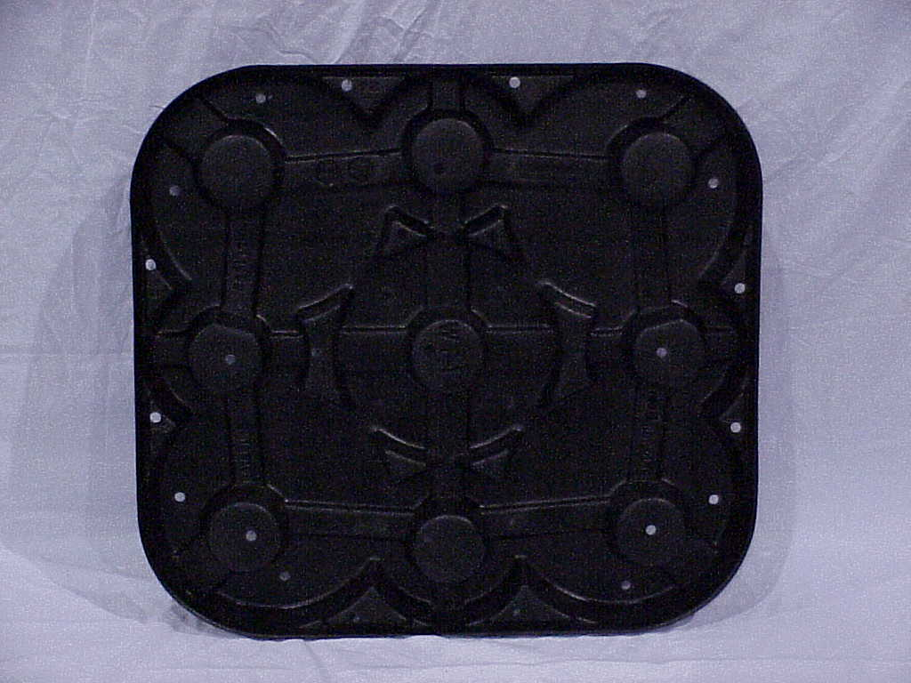
WT-12
- MD Clutch Tray
- Container: GM5332
- Dimensions: 29.0” x 27.0” x 4.0”
- # of Pockets: 9
- Pocket Diameter: 7.0”
- Weight: 5.5 lbs.
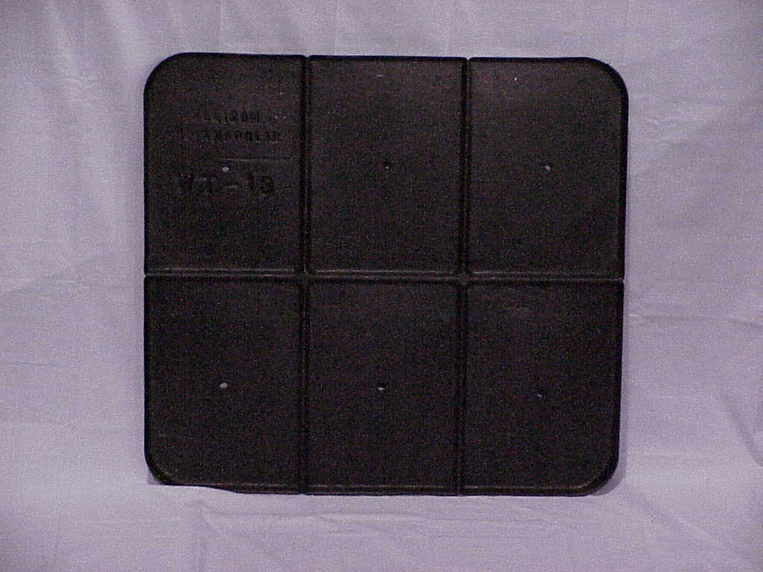
WT-13
- Tray
- Container: GM5332
- Dimensions: 29.0” x 27.0” x 1.0”
- # of Pockets: 6
- Pocket Size: 13.5” x 9.5” x 1.0”
- Weight: 5.08 lbs.
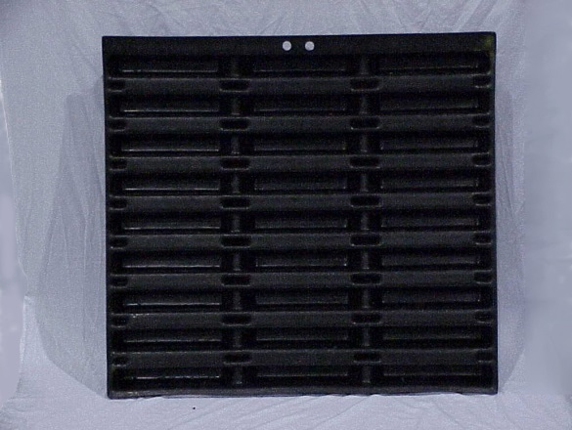
WT-19
- WT Front Support Tray
- Container: GM5348
- Dimensions: 40.0” x 44.0” x 5.0”
- # of Pockets: 27
- Pocket Size: 12.0” x 2.0” x 4.0”
- Weight: 40.0 lbs.
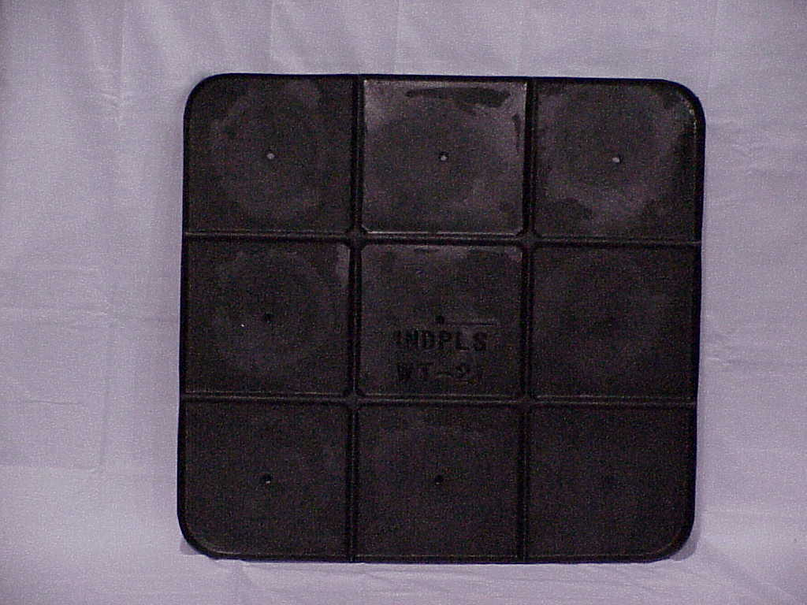
WT-21
- Tray
- Container: GM5332
- Dimensions: 29.0” x 21.0” x 1.0”
- # of Pockets: 9
- Pocket Size: 8.3” x 9.125” x 1.0”
- Weight: 5.36 lbs.
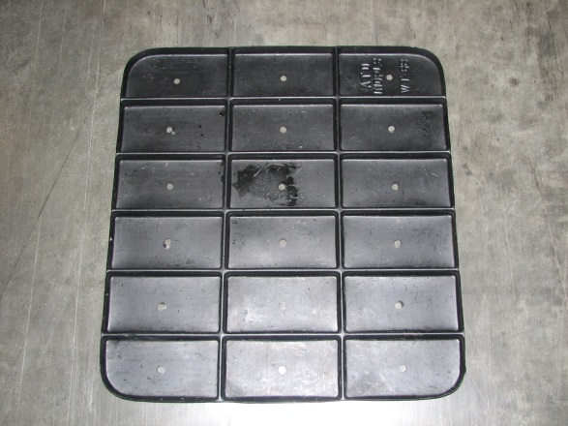
WT-68
- Tray
- Container: GM5332
- Dimensions: 29.0” x 21.0” x 0.5”
- # of Pockets: 18
- Pocket Size: 4.5” x 8.5” x 0.5”
- Weight: 4.3 lbs.
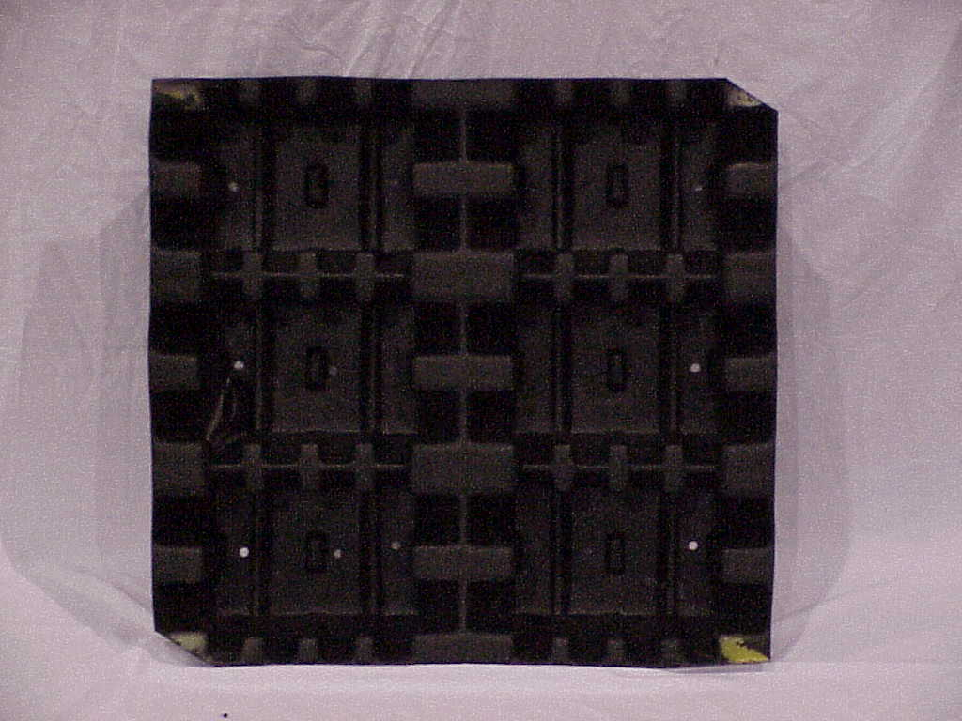
WT-69
- HD Clutch Pack
- Container: GM5332
- Dimensions: 29.0” x 27.0” x 5.0”
- # of Pockets: 6
- Pocket Size: 10.0” x 7.0” x 5.0”
- Weight: 5.5 lbs.

Other Dividers

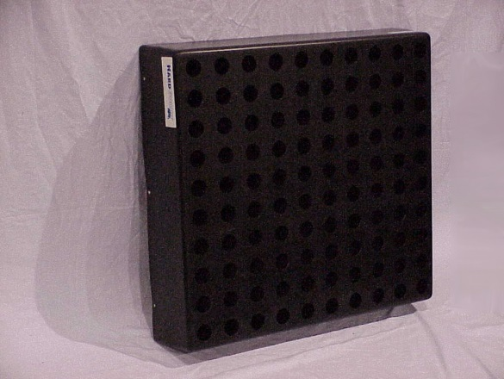
SA-1059
- 1000/2000 Main Shaft Divider
- Container: GM5332
- Dimensions: 29.0” x 27.0” x 5.0”
- # of Pockets: 100
- Pocket Diameter: 1.5”
- Weight: 12.0 lbs.
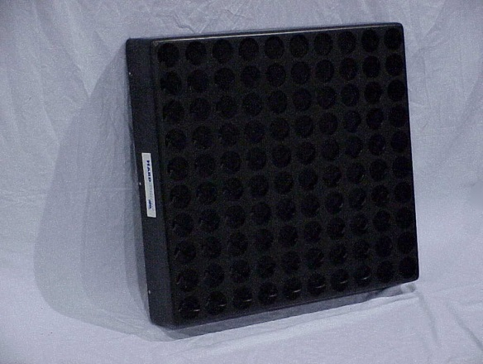
SA-1060
- Shaft/Sleeve Divider
- Container: GM5332
- Dimensions: 29.0” x 27.0” x 5.0”
- # of Pockets: 100
- Pocket Diameter: 2.25”
- Weight: 12.0 lbs.

Returnable Tote Containers

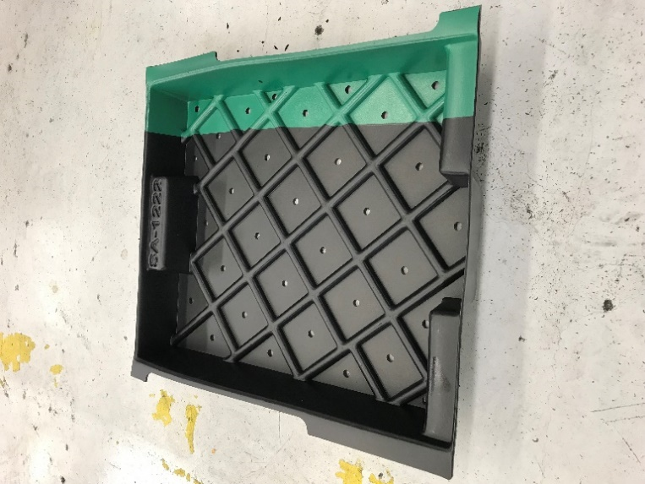
SA-1222
- Small Hand Held Tote
- OD: 13.40” X 14.39” X 2.25”
- ID: 11.16” x 11.71” X 1.43”
- Weight: 1.5 lbs.
- Capacity: 35 lbs. (including container)
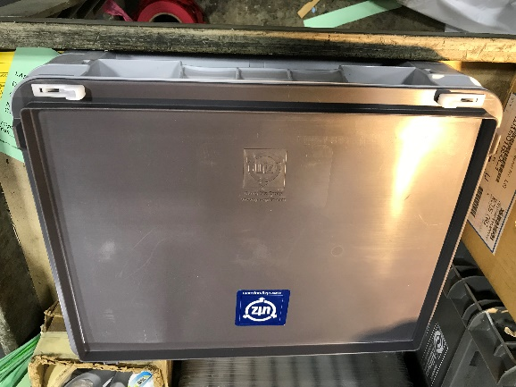
SA-1245
- Valve Tote
- OD: 15”x12”x 6.75”
- ID: 13 x 9.50 x 4”
- Weight: 3
- Capacity: 35 lbs. (including container)

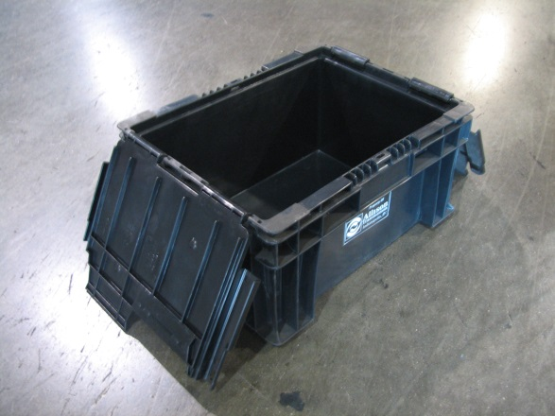
151208 (also known as BH SW 15x12x08)
- Straight Wall Tote mfg. by Buckhorn
- OD: 15” x 12” x 7.5”
- ID: 13.0” x 9.38” x 6.88”
- Weight: 3.0 lbs.
- Capacity: 35 lbs. (including container)
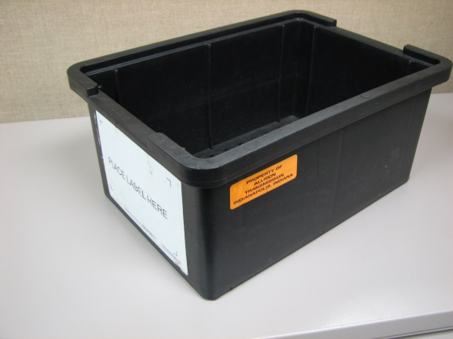
GMPT3411
- Straight Wall Open Tote
- OD: 14.63” x 10” x 6.63”
- ID: 12.88” x 8.75” x 6.0”
- Weight: 2.44 lbs.
- Capacity: 35 lbs. (including container)
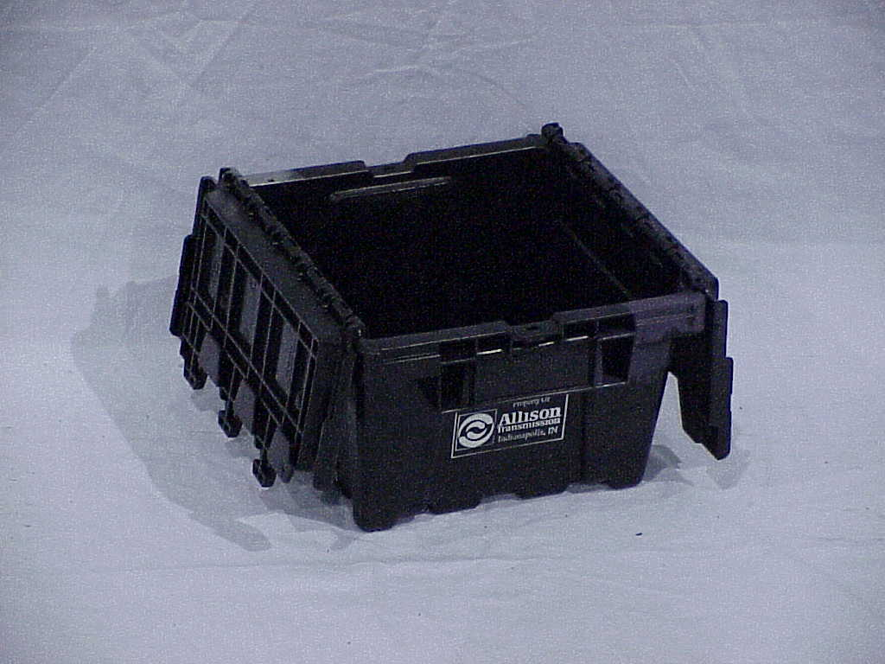
GM5310
- OD: 11.88” x 11” x 7.44”
- ID: 8.3” x 8.3” x 5.5”
- Weight: 3.1 lbs.
- Capacity: 35 lbs. (including container)
GM5312
- OD: 23.5” x 11” x 9”
- ID: 20.02” x 8.24” x 7.14”
- Weight: 6.2 lbs.
- Capacity: 35 lbs. (including container)

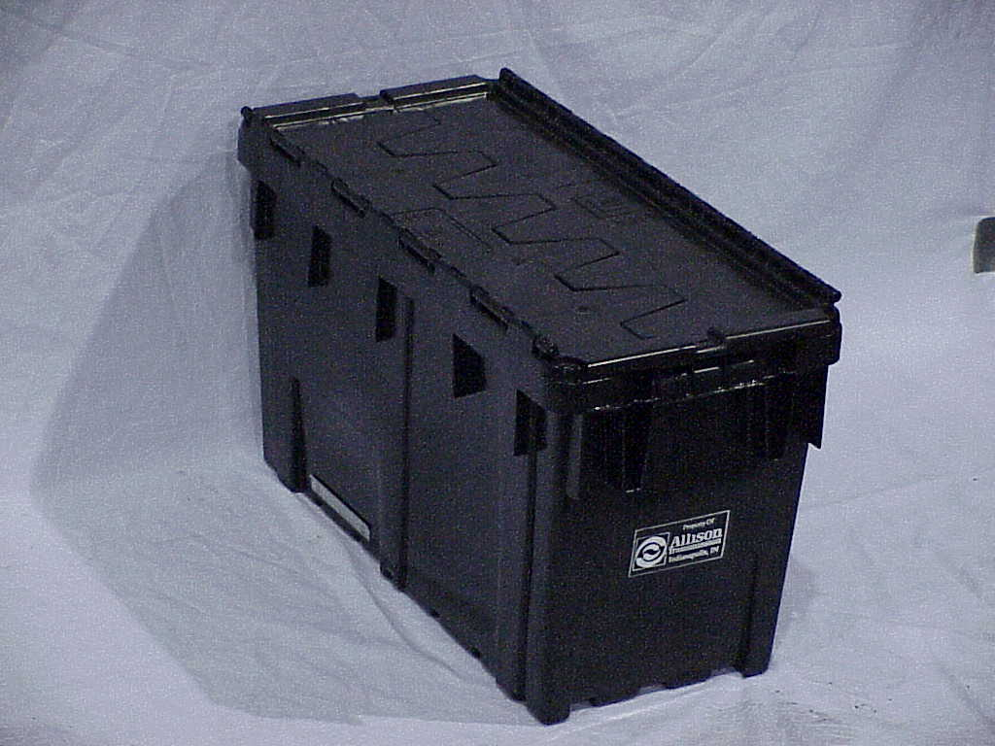
GM5314
- OD: 23.5” x 11” x 14”
- ID: 20.02” x 8.24” x 12.14”
- Weight: 7.63 lbs.
- Capacity: 35 lbs. (including container)
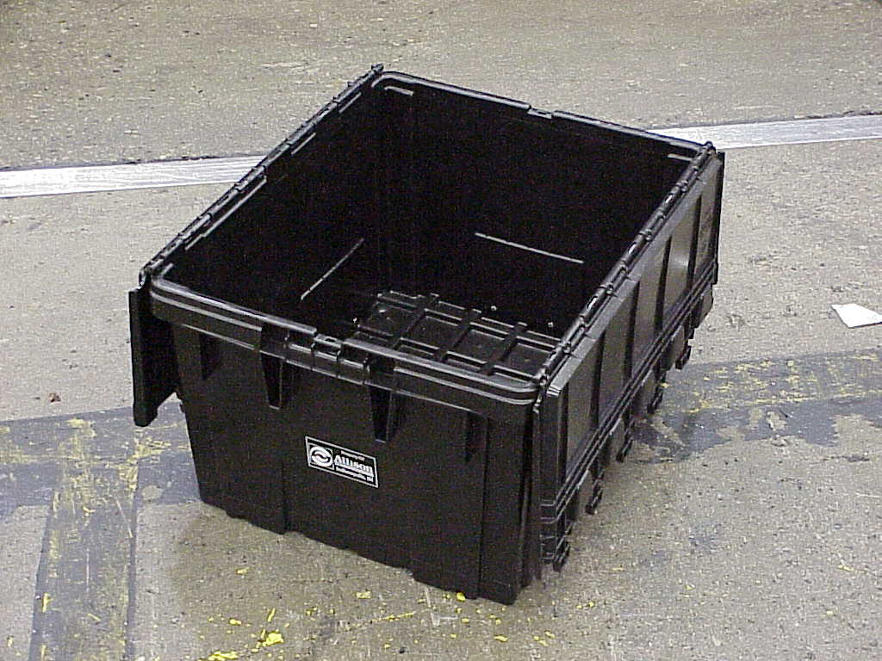
GM5316
- OD: 23.5” x 19” x 14”
- ID: 20.02” x 16.17” x 12.14”
- Weight: 10.94 lbs.
- Capacity: 35 lbs. (including container)
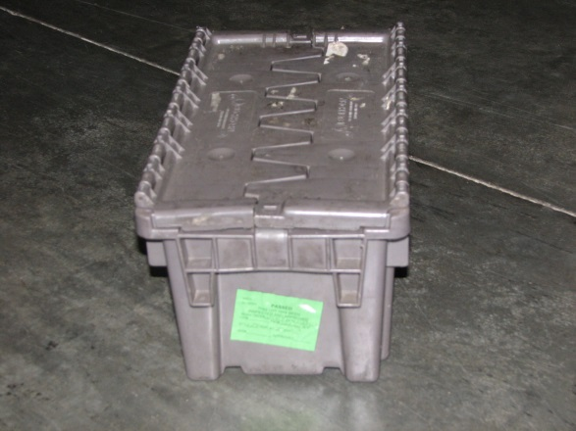
AIAG001
- OD: 14.82” x 8.13” x 7.25”
- ID: 13.5” x 7.38” x 6.5”
- Weight: 3.1 lbs.
- Capacity: 35 lbs. (including container)
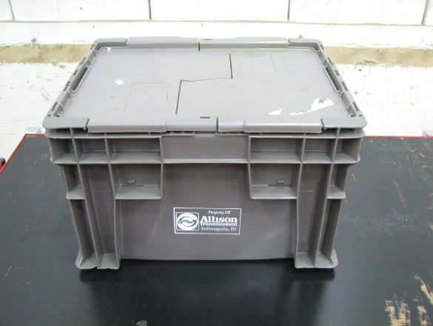
AC5313
- Straight Wall Tote-Grey
- OD: 12” x 15” x 9”
- ID: 11” x 14” x 8.5”
- Weight: 3.3 lbs.
- Capacity: 35 lbs. (including container)
- Taller version of 151208/BH SW 15x12x08

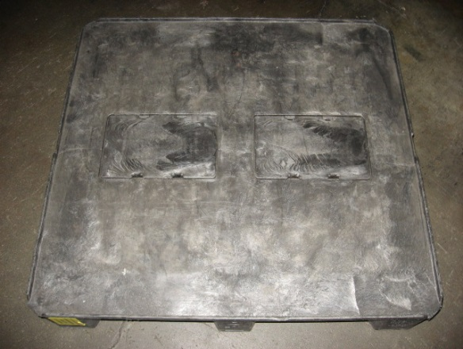
GM 5305 (first of two versions)
- Solid Deck Version
- Dimensions: 32.0” x 30.0” x 6.0”
- Weight: 25.7 lbs.
- Capacity: 1,200 lbs. (including pallet)
Returnable Pallets

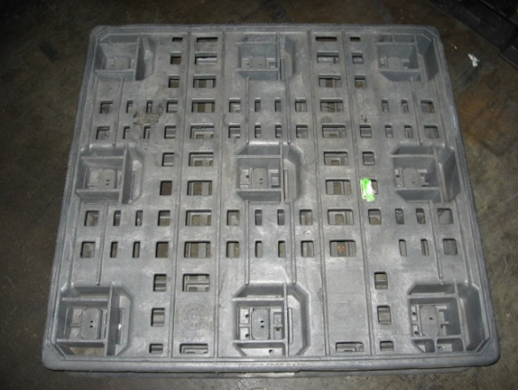
GM 5305 (second of two versions)
- Interlocking Deck Version
- Dimensions: 32.0” x 30.0” x 6.0”
- Weight: 25.7 lbs.
- Capacity: 1,200 lbs. (including pallet)
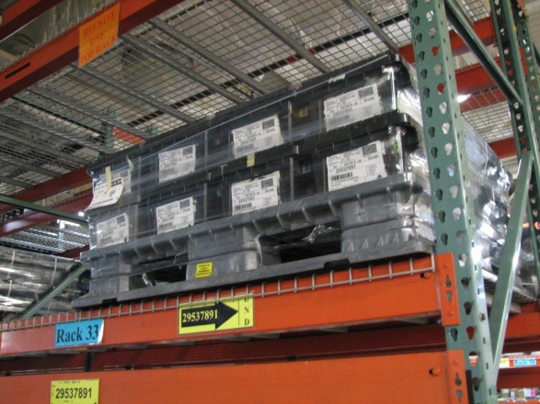

GM 5350 (shown with GM5310’s)
- Two photos
- Dimensions: 45.0” x 48.0” x 6.0”
- Weight: 59.0 lbs.
- Capacity: 2,000 lbs. (including pallet)
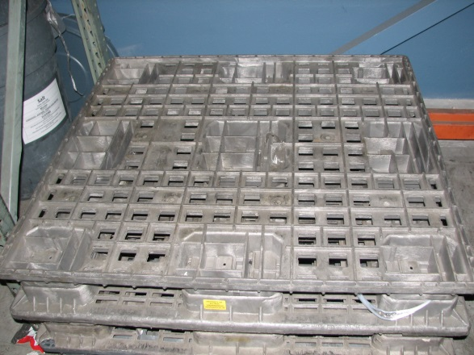

Banding & Wrapping (Tote Containers)

Purpose: Banding straps used properly will exert downward pressure on the contents of the tote as well as keep the lids shut. Bands are to be used going through the fork openings (pictured) of the pallet and will be sealed on top. Totes are to be banded across the “band slot” on the tote on the front side where the doors do not come down (pictured). A secured load will be less likely to be susceptible to harmful chatter, vibrations, and lids opening up that can be experienced during transit. Shrink wrap can also be used to keep the totes contained on the pallet.

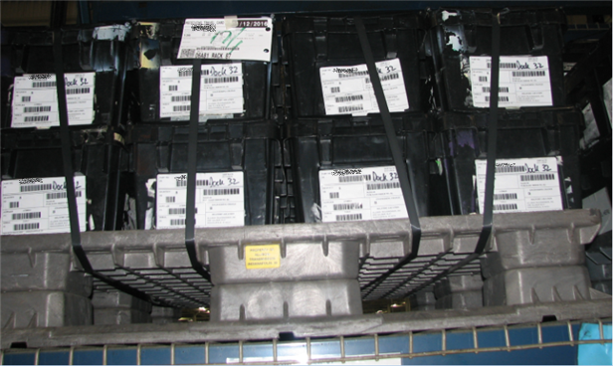
Banded through fork openings
Small cut out in container top for banding slot

Suppliers should seek advice from the Returnable Container coordinator if there are questions. Some known “Improper Techniques” are shown below.

In Summary, the banding should not damage or deform the containers. Steel banding should not be used.

Applies to: GM5310, GM5312, GM5314, GM5316, AIAG-001, AC5313, 151208 (also known as BH SW 15x12x08) on GM5350 and GM5305 pallet

Improper Techniques-see photo below

Figure 1: Banding going across the front of the container instead of the side where the slots are located
Figure 2: Four 4 or less returnable containers on a GM5350 returnable plastic pallet
Figure 3: Containers not stacked in all the same orientation
Figure 4: Containers that are banded shut all around the individual containers

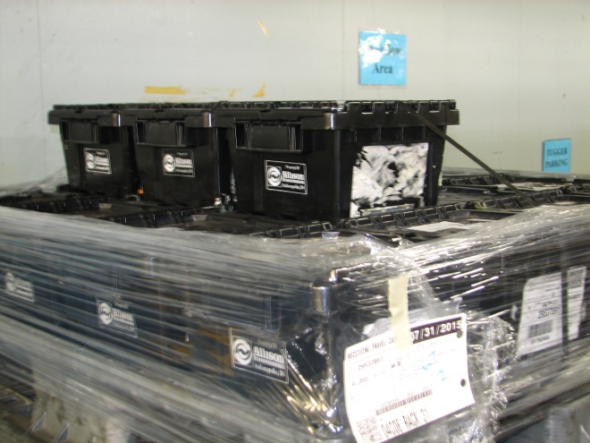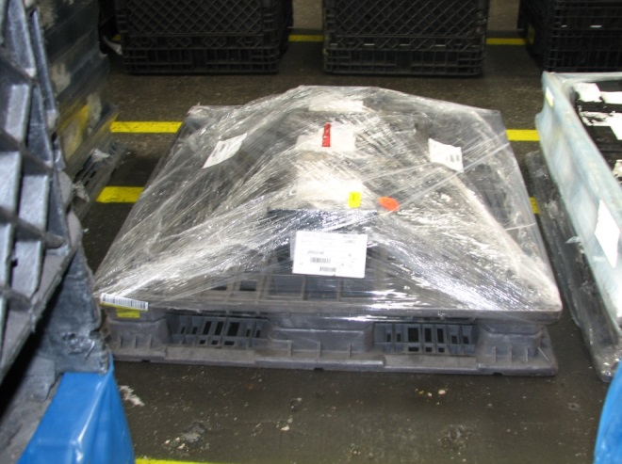
Figure 2

Figure 1

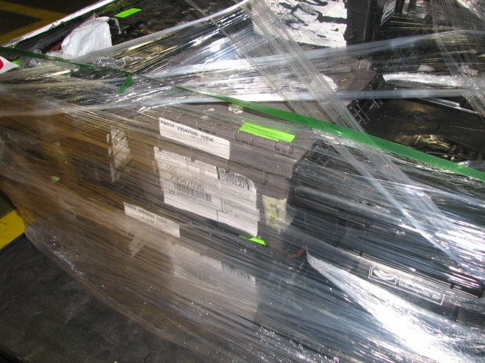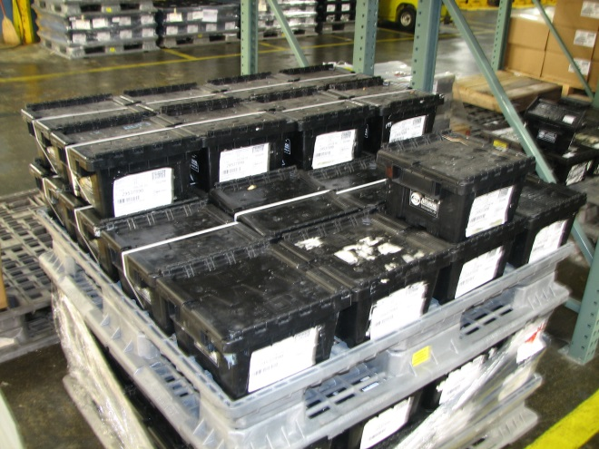
Figure 4

Figure 3

Oversized Dunnage (No Containers)

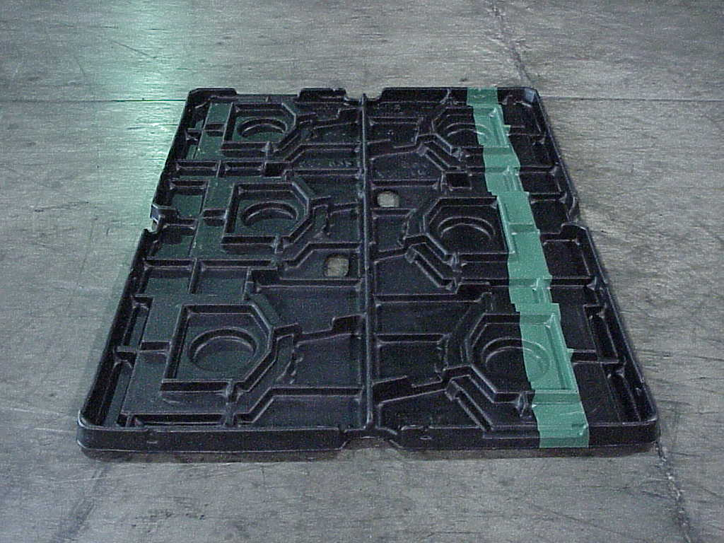
SA-972
- LCT Converter Housing Divider
- Color: Black w/ Blue Stripe on top
- Dimensions: 61.5” x 43.5” x 5.0”
- # of Pockets: 6
- Weight: 8.0 lbs.
Other Notes
- Used with a SA-1020P pallet and SA-1020L lid

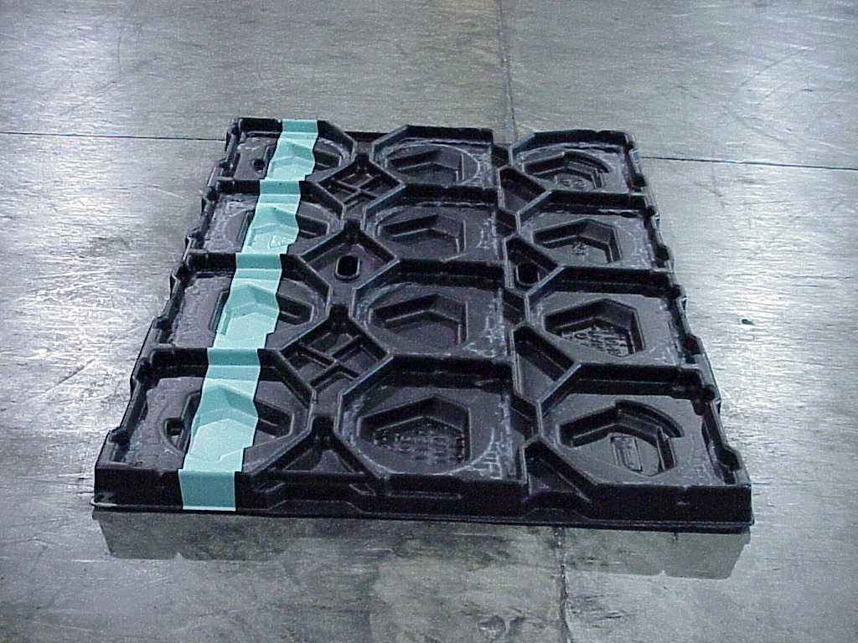
SA-973
- LCT Main Housing Divider
- Color: Black w/ Blue Stripe on top
- Dimensions: 61.5” x 43.5” x 5.0”
- # of Pockets: 12
- Weight: 8.0 lbs.
Other Notes
- Used with a SA-1020P pallet and SA-1020L lid
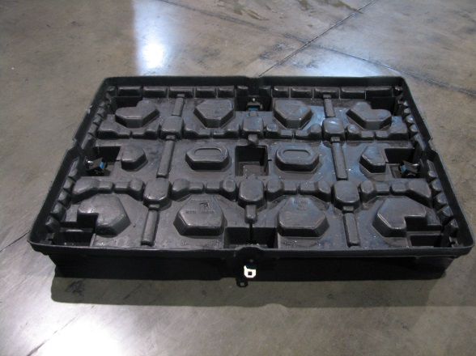
SA-1020P
- LCT Main Housing Pallet
- Dimensions: 61.5” x 43.5” x 6.0”
- Weight: 42.4 lbs.
- Has seat belt retractors to secure load with SA-1020L lid

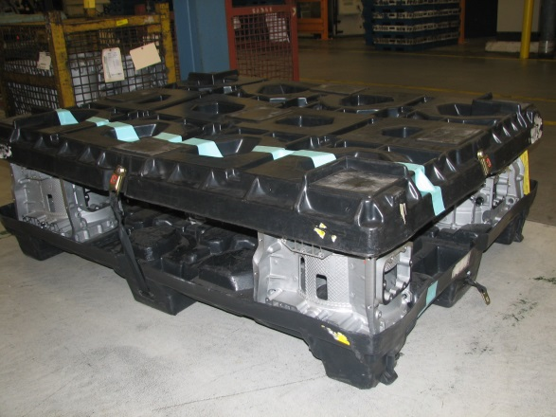
SA-1020L
- LCT Main Housing Lid
- Dimensions: 61.5” x 43.5” x 6.0”
- Weight: 22.9 lbs.
- Shown with SA-972 dividers
- SA-1020P pallet pictured with it
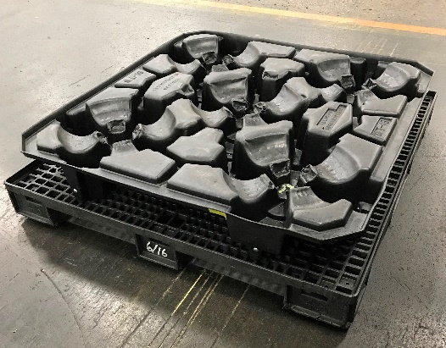
SA-1202
- MD Torque Converter Divider w/pallet
- Dimensions: 48.0” x 48.0” x 6.0”
- # of Pockets: 5
- Weight: lbs.

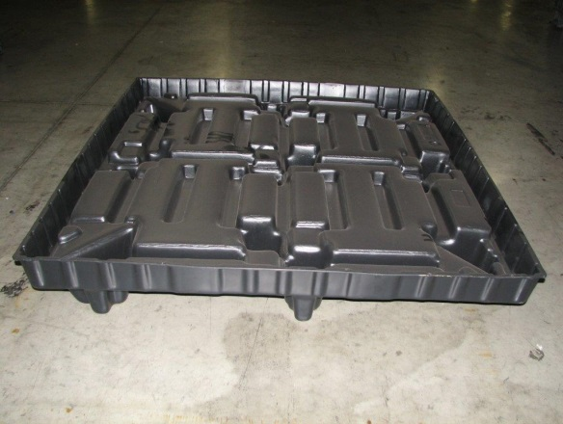
WT-16P
- MD/HD Torque Converter Pallet
- Dimensions: 48.0” x 48.0” x 6.0”
- Weight: 17.9 lbs.
- Used with Wt-16D and WT-17 dividers
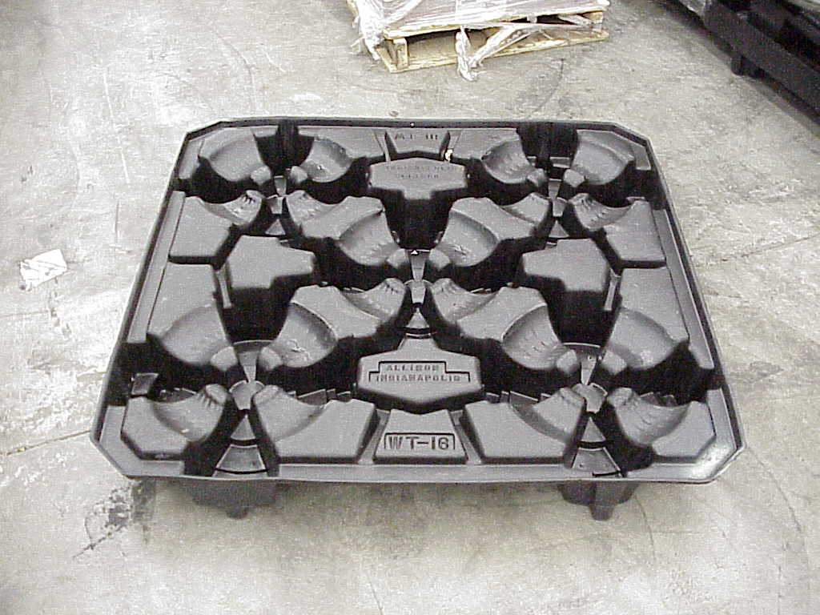
WT-16D
- MD Torque Converter Divider
- Dimensions: 48.0” x 48.0” x 6.0”
- # of Pockets: 5
- Weight: 18.0 lbs.
- Used with WT-16P pallet

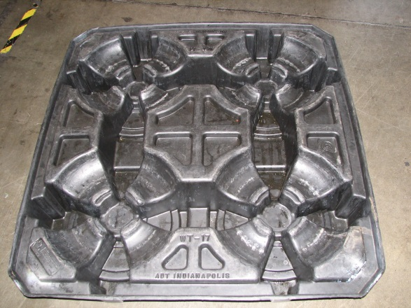
WT-17
- HD Torque Converter Divider
- Dimensions: 48.0” x 48.0” x 6.0”
- # of Pockets 4
- Weight: 18.0 lbs.
- Used with WT-16P pallet

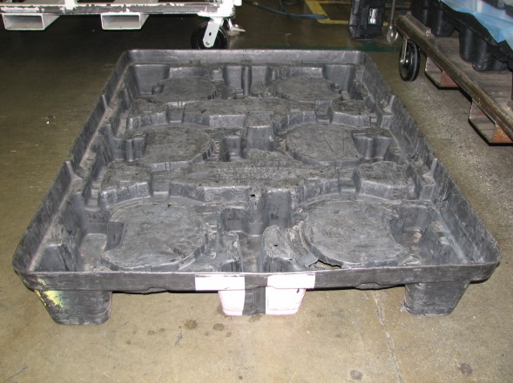
WT-20P
- MD Main Case/Converter Pallet
- Color: Black w/ Pink Stripe
- Dimensions: 61.5” x 43.5” x 6.0”
- Weight: 32.8 lbs.
- Used with WT-20D divider
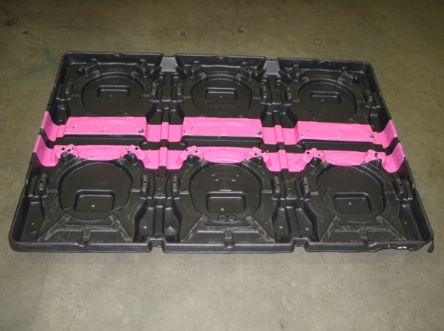
WT-20D
- MD Main Case/Converter Divider
- Color: Black w/ Pink Stripe
- Dimensions: 61.5” x 43.5” x 6.0”
- # of Pockets: 6
- Weight: 19.2 lbs.
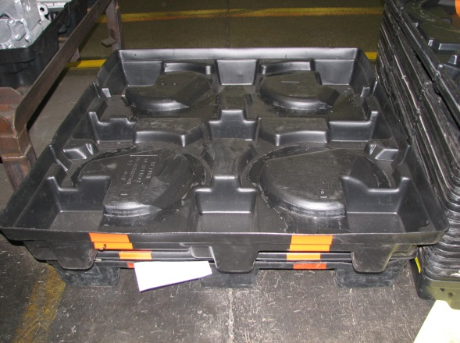
WT-64P
- HD Main Case/Converter Pallet
- Color: Black w/ Orange Stripe
- Dimensions: 54.0” x 47.5” x 7.5”
- Weight: 22.2 lbs.
WT-64D
- HD Main Case/Converter Divider
- Color: Black w/ Orange Stripe
- Dimensions: 54.0” x 47.5” x 7.5”
- # of Pockets: 4
- Weight: 21.5 lbs.

Miscellaneous Objects and Containers

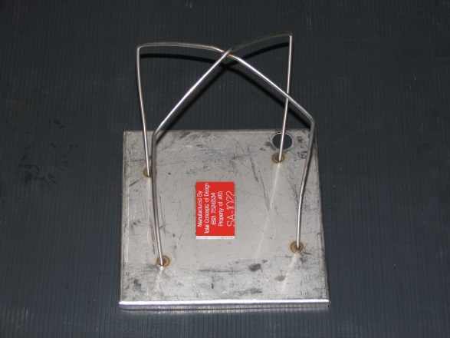
SA-1022
- LCT C5 Spring Pack Tower
- Container: GM5332
- Dimensions: 8.0” x 8.0” x 12.0”
- Pieces Per Tower: 9
- Weight: 5.32 lbs.
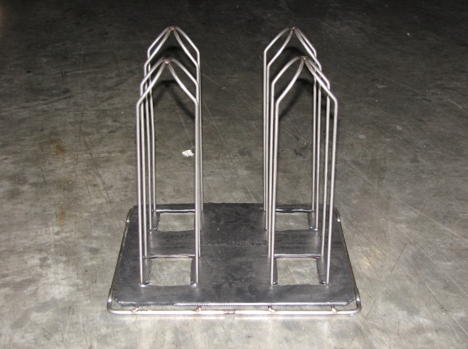
SA-1115 (spring tower alone)
- LCT C1/C2 Spring Pack Tower
- Container: GM5332
- Dimensions: 14.0” x 14.0” x 16.0”
- Pieces Per Tower: 40
- Weight: 4.0 lbs.
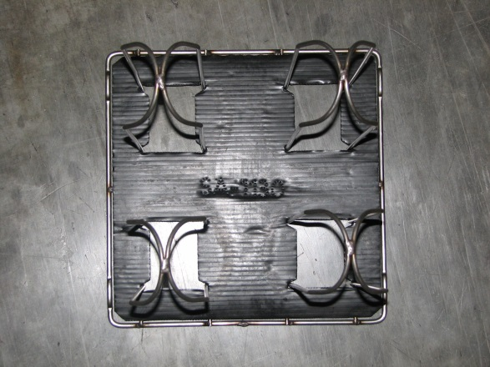
SA-1135 (pad attached to SA-1115 spring tower)
- LCT C1/C2 Spring Pack Layer Pad
- Container: GM5332
- Dimensions: 29.0” x 27.0” x 0.25”
- Pieces Per Tower: 40
- Weight: .2 lbs.
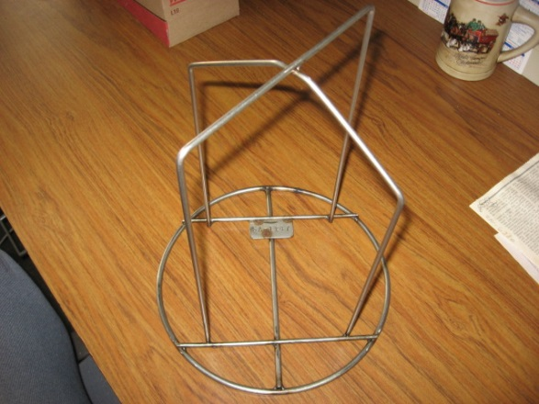
SA-1147
- LCT C3/C4 Spring Pack Tower
- Container: GM5332
- Dimensions: 14.0” x 14.0” x 16.0”
- Pieces Per Tower: 40
- Weight: 1.3 lbs.
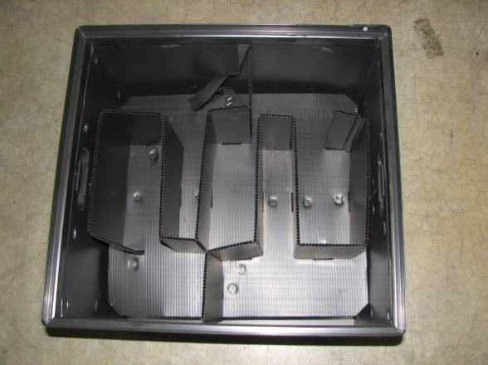
SA-1194 (Tote) with two SA-1187 dividers
- TC-10 Shift Fork Partition and Tote
- Container: 4 totes in GM5320
- Dimensions: 21.93” x 20.5” x 16.1”
- # of Pockets: 4 in each SA-1187
- Weight: 7.0 lbs.
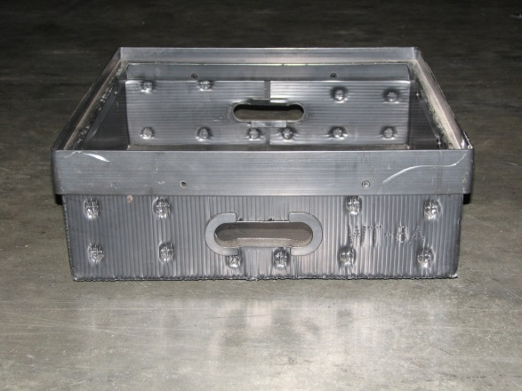
WT-08
- Hand Held Corrugated Plastic Tray
- Color: Black or White
- OD: 19.0” x 18.0” x 4.0”
- ID: 17.5” x 16.25” x 4.0”
- Weight: 3.5 lbs.
Steel Returnable Component Racks

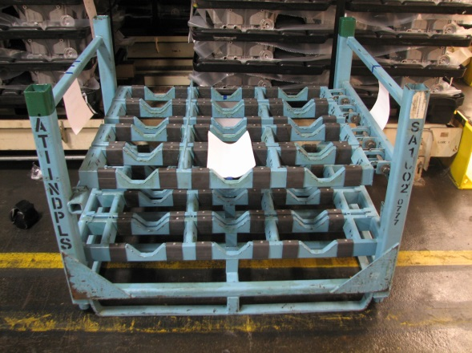
SA-1002
- Torque Converter Rack
- Color: Blue w/ Green striped corners
- Dimensions: 53.0” x 44.0” x 40.0”
- Weight: 685.0 lbs.

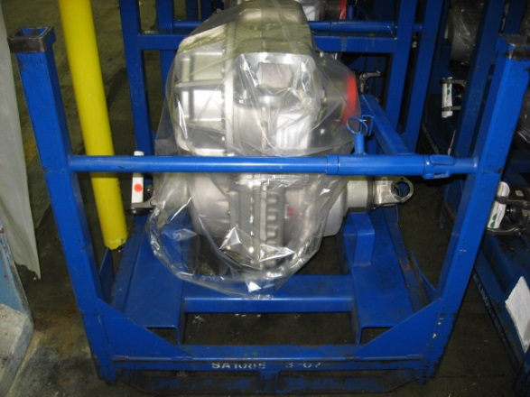
SA-1085
- MD07 Transfer Case Rack
- Color: Blue
- Dimensions: 32.5” x 35.0” x 38.0”
- Weight: 240.0 lbs.
- Holds 1 transfer case assembly

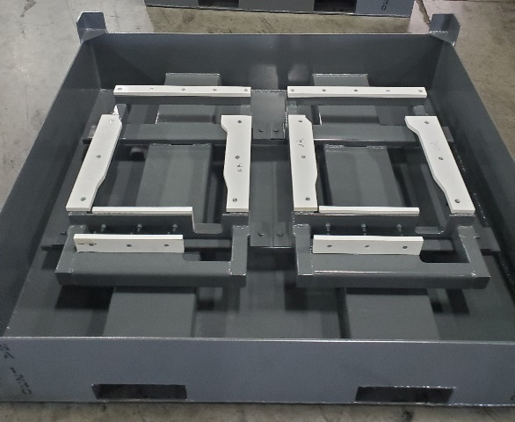
SA-1230

- Color: Gray : Dark Grey
- Dimensions: : 45L x 51W x 14H
- Weight: 475 lbs

Transmission Rack

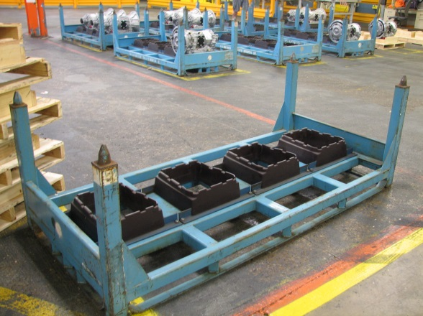
SA-1011
- 1000/2000 Series Shipping Rack
- Color: Blue
- 4 – place
- Dimensions: 90.0” x 42.0” x 33.0”
- Weight: 515.0 lbs.
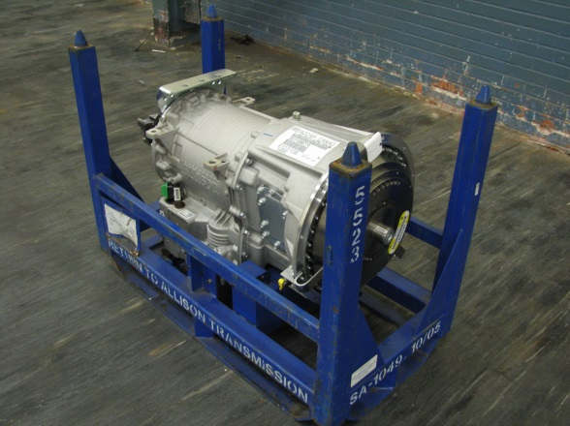
SA-1049
- 3000 Series Shipping Rack
- Color: Blue
- Dimensions: 45.0” x 22.5” x 33.0”
- Weight: 185.0 lbs.
- One place
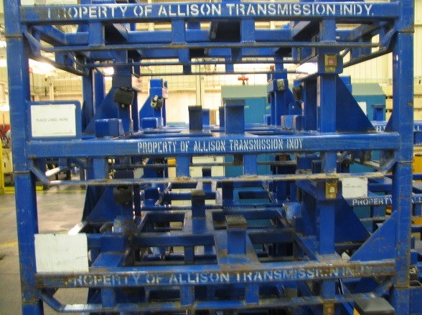
SA-1079
- MD07 3000 Series Shipping Rack
- Color: Blue
- Dimensions: 45.0” x 60.0” x 32.0”
- Weight: 417.0 lbs.
- Two place

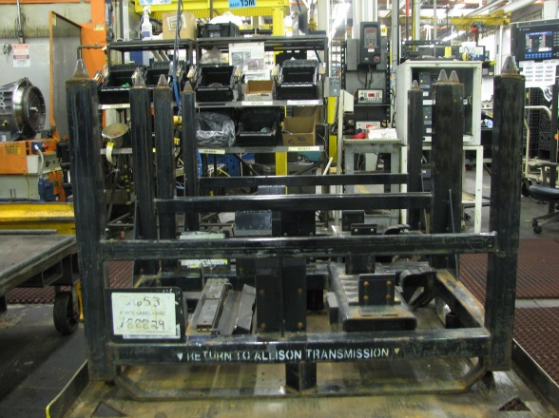
SA-1104
- 4000 Series Shipping Rack
- Color: Black
- Dimensions: 45.0” x 28.0” x 36.0”
- Weight: 220.0 lbs.
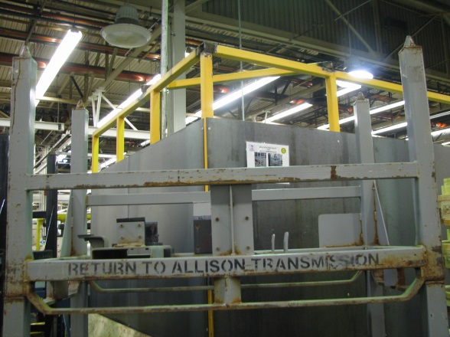
SA-1117
- 4000 Series Shipping Rack
- Color: Gray
- Dimensions: 55.0” x 26.0” x 38.0”
- Weight: 230.0 lbs.
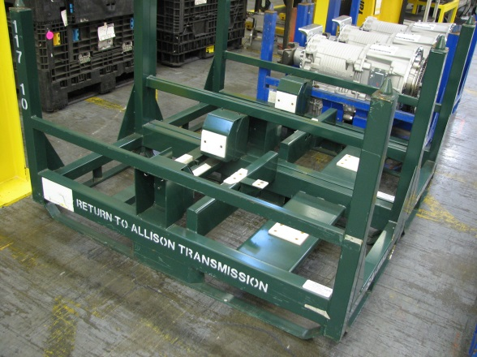
SA-1162
- 3000 Series Shipping Rack
- Color: Green
- Dimensions: 63.0” x 32.0” x 38.0”
- Weight: 296.0 lbs.
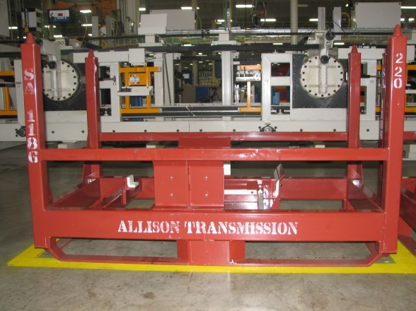
SA-1186
- TC-10 Transmission Rack
- Color: Red
- Dimensions: 63.0” x 32.0” x 42.0”
- Weight: 185.0 lbs.
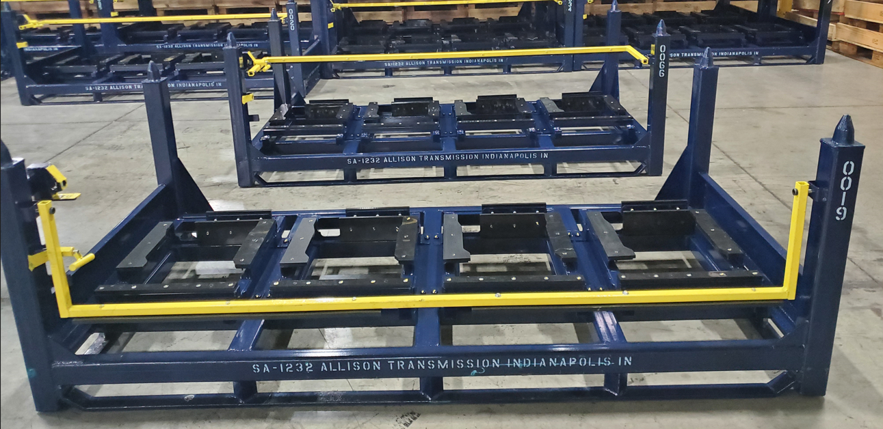
SA-1232
- IconIX Series Shipping Rack
- Color: Blue
- 4 – place
- Dimensions: 90.0” x 42.0” x 33.0”
- Weight: 553.0 lbs.

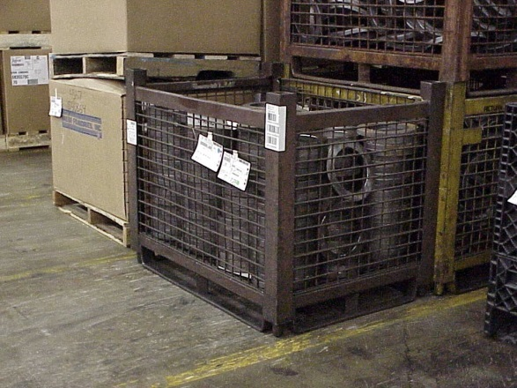

SA-568
- Dimensions: 44.0” x 32.0” x 35.0”
- Weight: 265.0 lbs.
- Capacity: 2,250 lbs. (including basket)
- May have one or two gates
- Two photos provided
Wire Baskets

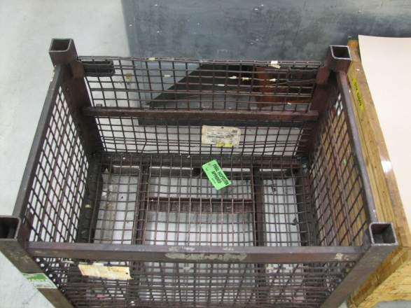
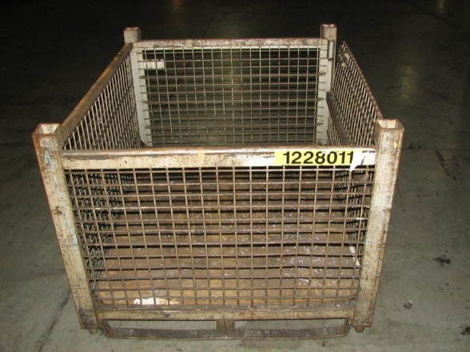
SA-592
- Dimensions: 44.0” x 53.0” x 35.0”
- Weight: 390.0 lbs.
- Capacity: 2,250 lbs. (including basket)
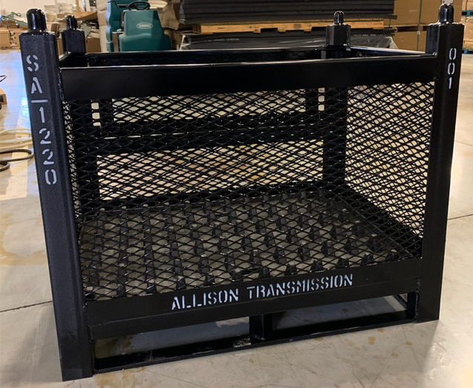
SA-1220
- Dimensions: 44.0” x 32.0” x 35.25”
- Weight:
- Capacity: 2,250 lbs. (including basket)

